4 A Meditation
Fucking You
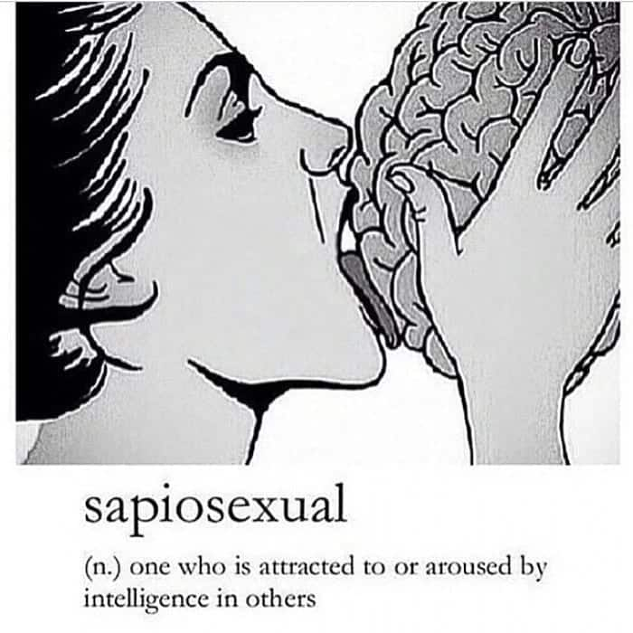

2022Dec15@1715pm in Iowa

[ Honesty by Billy Joel ]

Fucking you
Is all I want to be
But everything is so confused...

[ Piano man ? ]

Seriously
Let’s just chat
Sheet plate of glass between us
no fucking
Just, “how have you been?”

Cuz I want to see:
(no apologies)
let’s talk like 2 humans,
eye-to-eye,
one interesting human to another...

...For instance, why don’t you write (in your blog) no more?



[ desktop 2022 pixie cut, pale tits with tats.jpg ]

[ Pussy Popping by Ludacris ]

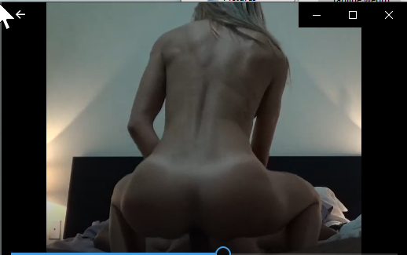

[ squat cowgirl tanline.webm ]

Remember this? How often do you do this with other people?



[ very loud dick spider.webm]

And why do you make so much noise during intercourse? It is sexy as fuck, and at the same time, rather inconvenient when we have sex next door to the landlord.

Sexy as fuck tho.

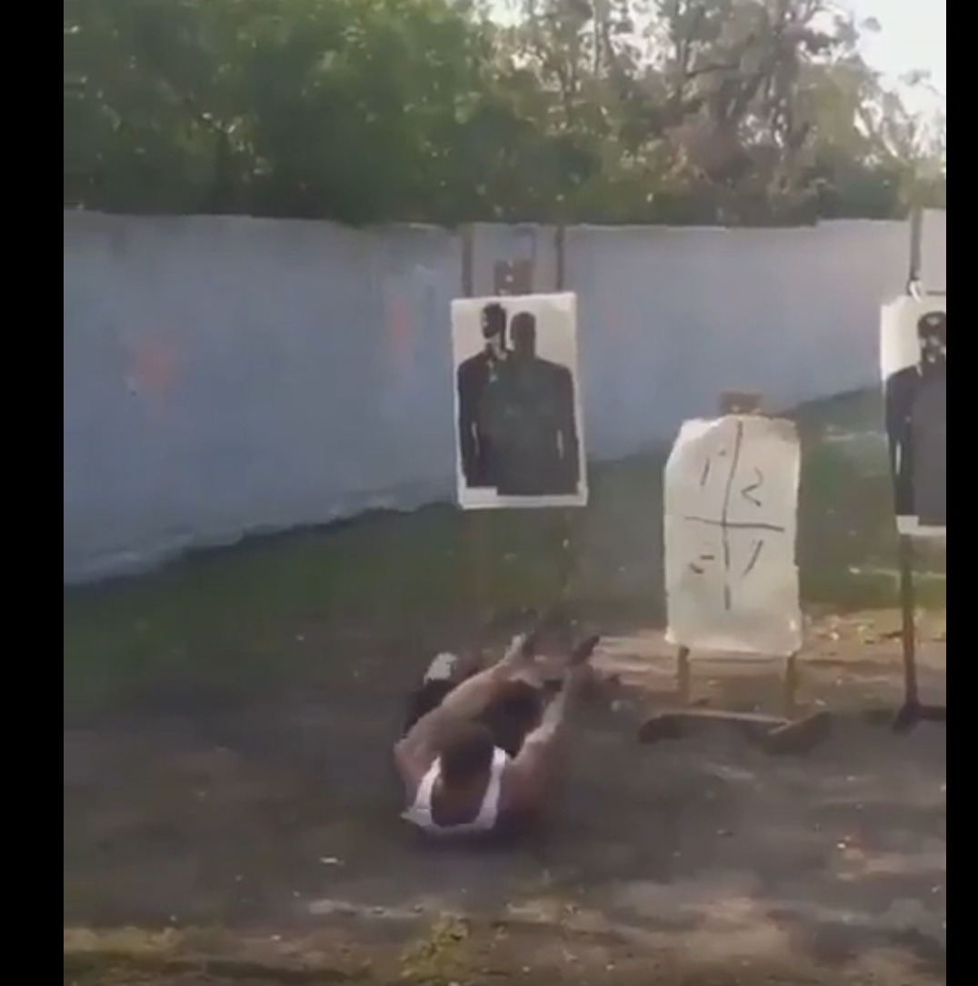

[ john wick wannabe.webm ]

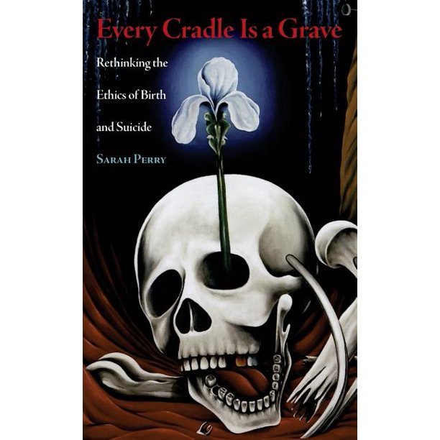

Every Cradle Is a Grave by Sarah Perry

Yasuha • Flyday Chinatown
https://youtu.be/5syUvHEQcv8
via via 80s japanese city pop playlist 1 | Part 1 | Red Collection Playlist


[ Cardi B & Bruno Mars - Please Me (Lyrics)][ambiguous expression.jpg ]

[ Cardi B - WAP (Lyrics) feat. Megan Thee Stallion ]]


[ 180 cowgirl white on black.webm ]

Love “quasimoto on wax”’s vibe tho. It’d be great to get a portrait of you done by him

I don't want to love, you
I just want to fuck, you
You should bring your friends, through
I'll fuck you and them, too

[Verse 3]
I know you love the way I'm diggin it out
I know it's hard to talk with all this dick in your mouth
Menage-a-trois, for moi, let's figure this out
I drink a Hennessy fifth and sweat the shit out
She don't gotta cheat cause it's a waste of her time
She'll never find another dick that's bigger than mine
Hands and knees side by side, I hit from behind
Flip it up, givin a fuck, we fuck all night

https://youtu.be/EUGogShQA7o?t=131
Xzibit ft. Traci Nelson - Choke Me, Spank Me (Pull My Hair)

Just lay back, relax to the sounds of the sex
And let me do what I do until you climax
You can go straight to sleep after it's all over
In the morning, roll over and we can start over

50 Cent - So Amazing (feat. Olivia)
https://youtu.be/6QTeTMlOJI0?t=50

Aiyyo my party people dance to this (uh)
Get ya roll on, wave ya hands to this (what)
Ladies show ya thong, drop ya pants to this (wha-what)
Hop inside the Benz and get tampered with
You can get it even if your glamourous, feel me, feel me?
The way you shake that ass it's like you tryin to kill me
I'm sick with the sex you need, so baby heal me
Its Teddy Ted and Made Men, what you forgot me?

Benzino feat. Fabolous, G Dep - Booty
https://youtu.be/Fu0gWiBVc58?t=70

Wait until you see how much I like booty.
That’s why I call you Infinibooty
and that’s NO fluke.

'Cause we like her (Hey), and we like her, too
And we like her (Hey), and we like her, too
And we like her (Hey), and we like her, too
And we like her, and she like us too, and oh...
I wish I could fuck every girl in the world
EveryGirl In The World-Young Money [Explicit, HQ]
https://youtu.be/rbBHnWY0gns?t=205

Can we be compatible knowing how MUCH I love pussy?
And girls?

Sadly, making money from one’s love of sex (or love, saudade) means staying on-camera 8 hours a day. Why wouldn’t you get sick bingeing like that on any one desire? Shit.

Like we don’t have to do it 8 hours a day,
but more than once every 7 years.

My role model was Wilt, so, married women or MILF
It don't matter who you is, miss—you can get "Tha Bizness"

For free suites, I'd give Paris Hilton all-nighters
In about three years, holla at me, Miley Cyrus

EveryGirl In The World-Young Money [Explicit, HQ]
https://youtu.be/rbBHnWY0gns?t=265

Like, really, in some sense you can’t blame Jeffrey...

Kanye West & Lil Pump - I Love It feat. Adele Givens [Official Music Video]
https://youtu.be/cwQgjq0mCdE?t=66

...Or R. Kelly.

Like a flower fully bloomed in the summertime, you're ready
To be watered by this conversation, hope you're ready
I'm in awe cause you shine like the sun
Let me be the one to enjoy you (Enjoy you)
Let's kick it girl
Bobby V. - Slow Down (Official Music Video)
https://youtu.be/Z6NzwMif0fA?t=145

Like, do you know how unlikely it is that we know of each other? Ridiculous. (do you know how unlikely it is!?)
People pay homage to love, and art, and beauty
but aren’t real good at appreciating it, it seems.

And YOUR ass IS (real good at appreciating love, art, and beauty).

https://www.youtube.com/watch?v=y2bVIBwpCTA
The Jackson 5 "I Want You Back" on The Ed Sullivan Show

In case we’re being too subtle
Take this title literally.

Oh, girl... One more chance with you again I will not let it go!
Oh, please! Give me just one more chance for love, love, love, love
https://youtu.be/3SoYkCAzMBk?t=179
Tevin Campbell - Can We Talk (Official Video)

Oh-oh, I'm grateful for your existence
Faithful no matter the distance

Justin Bieber - All That Matters
https://youtu.be/JC2yu2a9sHk?t=119

Don’t take the TITLE of this one literally. Its just a damn sexy song with sexy fucking lyrics.
*sigh*
Could we have a mental affair?

I aint’ getting caught, tho
and it seems cheaters either get caught,
or confess (themselves)

And to your own needs:
You don’t need that drama in your life
Hear! Hear!

So back to the issue at hand: mental affairs.

How about you start writing again?
And I promise to reply
at least once a year, for the next 4 years...

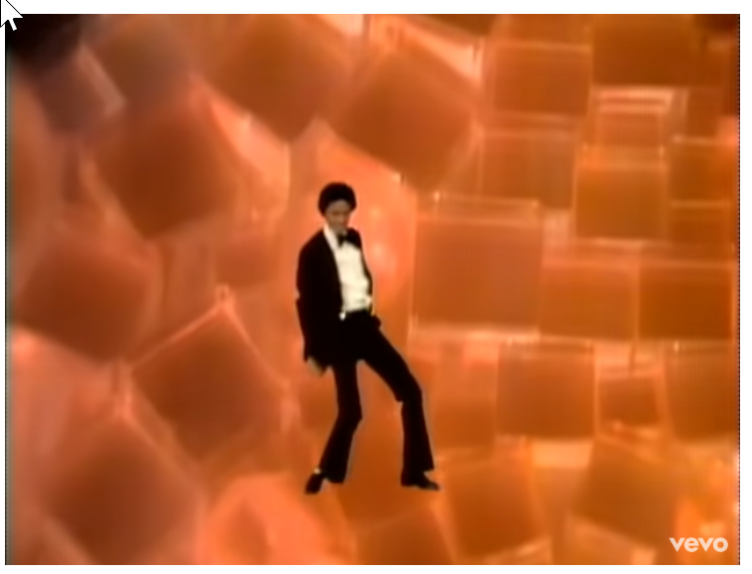

https://www.youtube.com/watch?v=yURRmWtbTbo
Michael Jackson - Don’t Stop 'Til You Get Enough (Official Video)

...cuz Your boy is grown,
and sexy...

...And sexy is what you need right now.

[ sapiosexual.jpg ]

@1722pm

FIN

https://www.youtube.com/watch?v=1YfDSm098mY
Amerie - Pretty Brown Eyes [ft. Trey Songz]

https://www.youtube.com/watch?v=sQgd6MccwZc
Destiny's Child - Say My Name (Official Video)

The remix of Lil Uzi Vert’s 7am by Knxwledge titled “whogivestro_”: track 10 on his album, “WT​.​13​.​8_​[​ラフミックス]”
https://knxwledge.bandcamp.com/track/whogivestro

https://www.youtube.com/watch?v=6iSY2qpPC7w
Fabolous feat Lil'Mo & Mike Shorey - Can't Let You Go

Rich Boy - Throw Some D's (Gravez VIP) (ft. Drewsthatdude)
https://soundcloud.com/dvckbeetshiphop/rich-boy-throw-some-ds-gravez-vip-ft-drewsthatdude

Drake - Trophies (Brasstracks Cover)
https://www.youtube.com/watch?v=fMyyXVi9rhk

Galimatias - Dahlia Petals
https://www.youtube.com/watch?v=GJC78Kv0aOE

bbhmm (jael dj edit) by PYRMDPLAZA x Gravez vs rihanna
https://soulection.com/tracks/GoylDd9G0hM/

U Da One (UpperClassmen Remix) via
Soulection Radio Show #185 w/ Fortune
https://soundcloud.com/soulection/soulection-radio-show-185-w-fortune?si=6c047d01f4d344eb8ca5bccaa5c3e62d&utm_source=clipboard&utm_medium=text&utm_campaign=social_sharing#t=1%3A33%3A33

