4aMeditation
Post-Coital


[ girls spooning.jpg ]

2022Dec17@1213pm

Side A: Foreplay
https://www.youtube.com/watch?v=02f76-YsTBw
Memory by Seatbelts from the Cowboy Bebop soundtrack
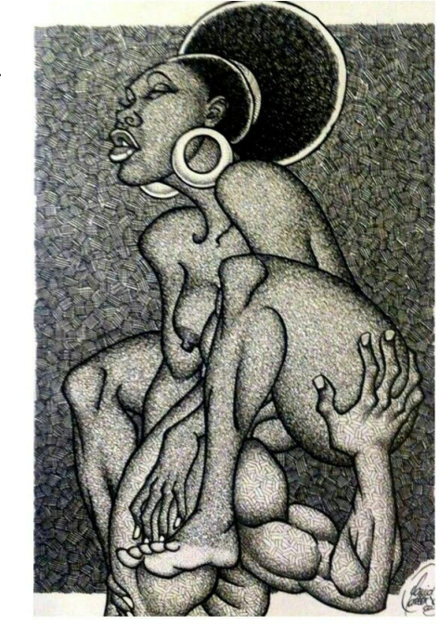

[ woodcut of sista getting head.png ]
Tank by Seatbelts
https://www.youtube.com/watch?v=UFFa0QoHWvE

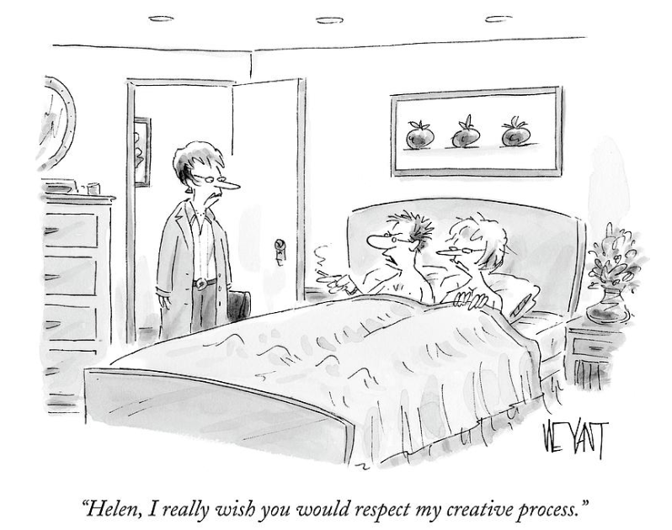
[ creative process.png ]

We can do it anywhere
I can love you in the shower, both of our bodies drippin' wet
On the patio, we can make a night you won't forget
On the kitchen floor, as I softly pull your hair
We can do it anywhere, anywhere
112 feat. Lil' Zane - Anywhere (1999)
https://youtu.be/ejtzsZq7A44?t=72


[ quazimotto on wax -- long tits with african max.jpg ]

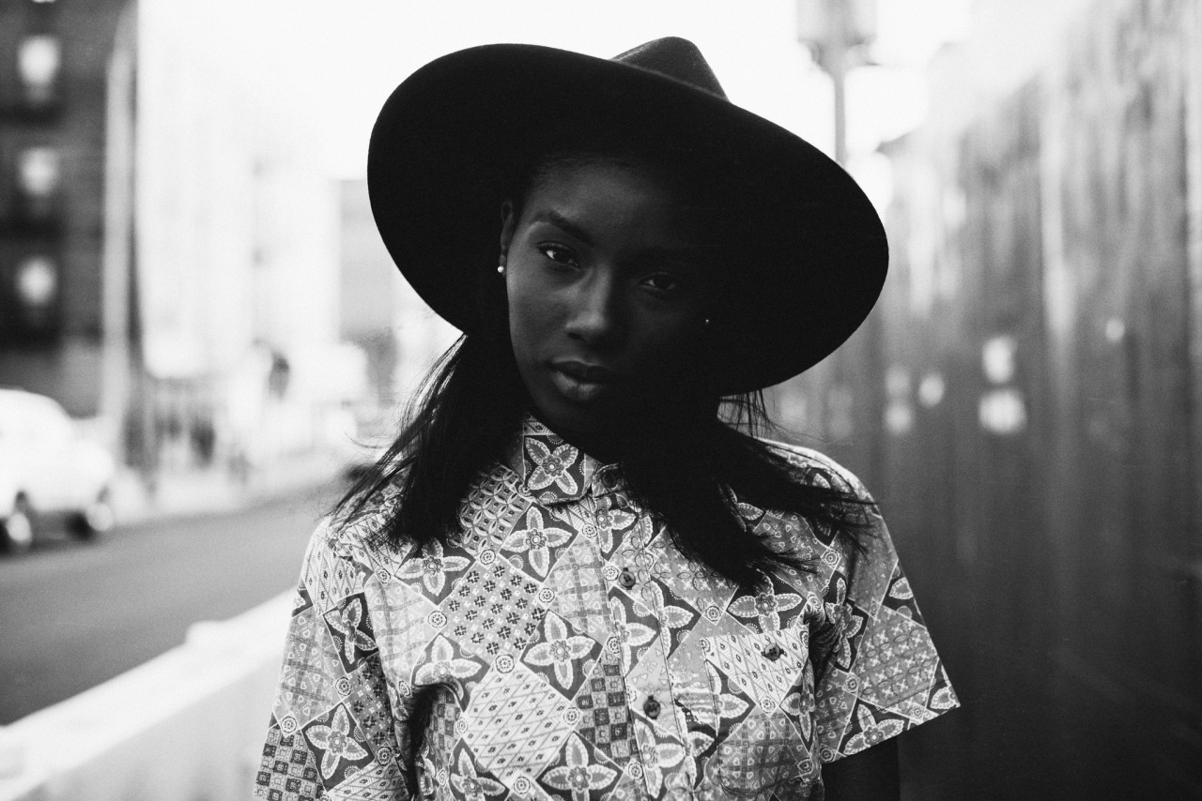
[ that look.jpg ]

Untold - Stop What You're Doing (James Blake Remix)
https://www.youtube.com/watch?v=szTrH6XgA_M&t=6s

That bass tho’

Mount Kimbie - Maybes (James Blake Remix)
https://www.youtube.com/watch?v=oLTPDFoT6sc


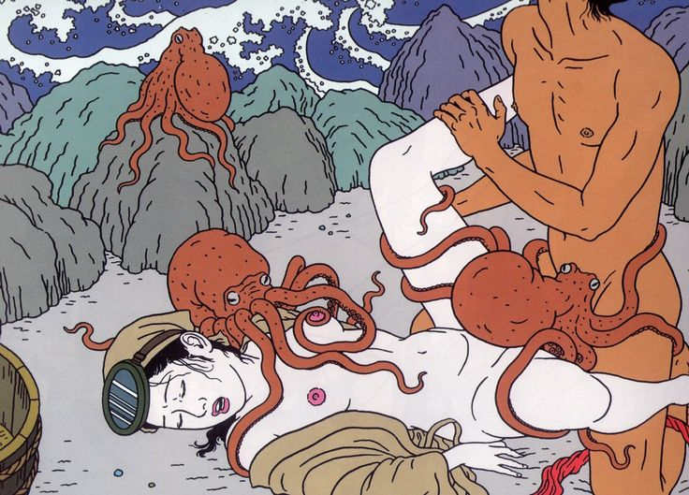
[ dream_of_the_fishermans_wife_hokusai.jpg ]
[ octo-mediated fucking.jpg ]

[ octo on schoolgirl.jpg ]
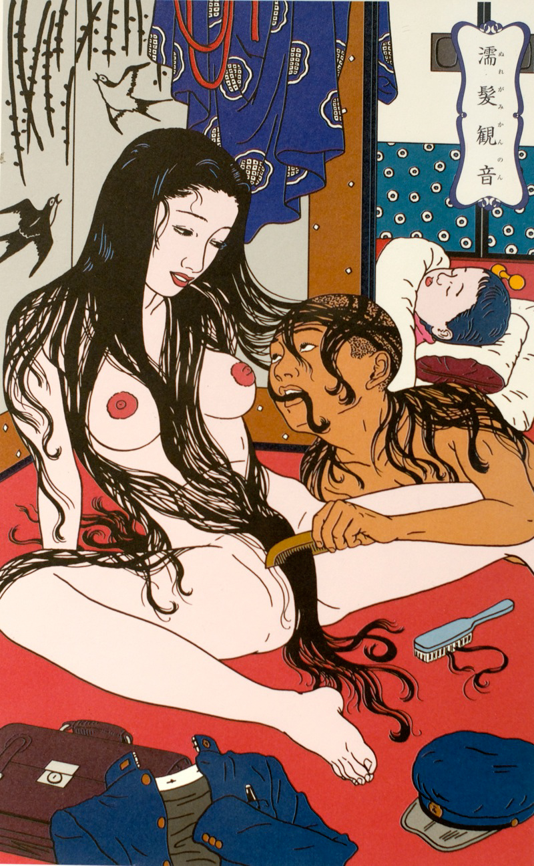


[ toy pleasuring.jpg ]
[ combing hair shared look.jpg ]
[ biting back while fucking.jpg ]
Again the bell rang and Munck was called for. This time, Munck wrote, the couple was in the wrong position, “because he will not rest on his arms, but rather places his whole weight on the Queen’s body.” Munck found that he was compelled to practice a “hands on approach” and had to move both the King and the Queen with his hands.

https://theesotericcuriosa.blogspot.com/2010_10_11_archive.html

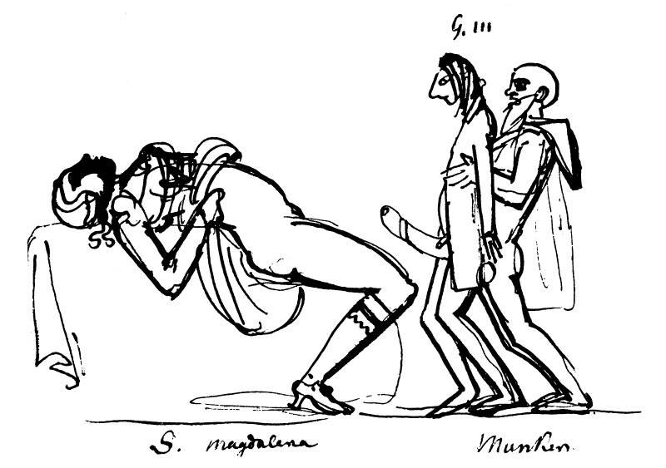
[ Sofia_Magdalena,_Gustav_III_och_Adolf_Fredrik_Munck.jpg ]

sad but lol.
I don't wanna go home
Shall we drive from zone to zone?
I wouldn't do this on my own
But I'm not on my own tonight

Oh, you're going to New York?
I’m going there
Why don’t I come with you?
Oh, you've changed to L.A.?
I’m going there, I can go there, too

https://www.youtube.com/watch?v=GOJ5HYGIqlY
James Blake - I'll Come Too

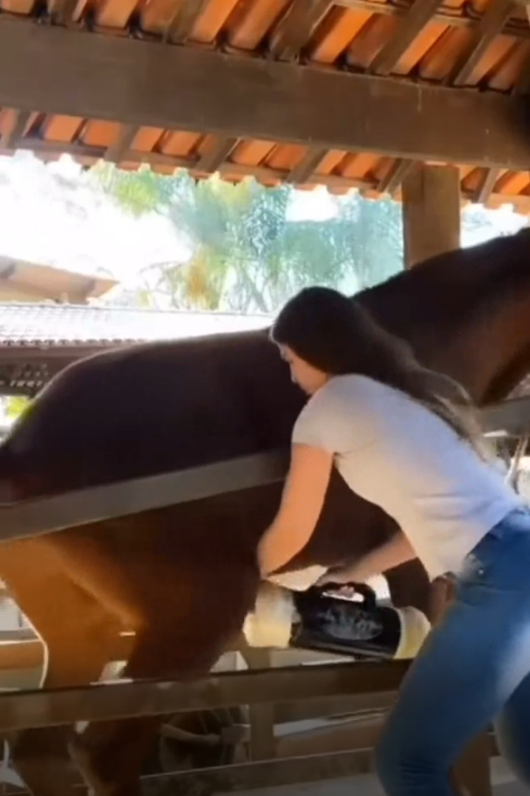

[ horse j-o.webm ]
Dru Hill - These are the times
https://www.youtube.com/watch?v=pktMoSZY75w

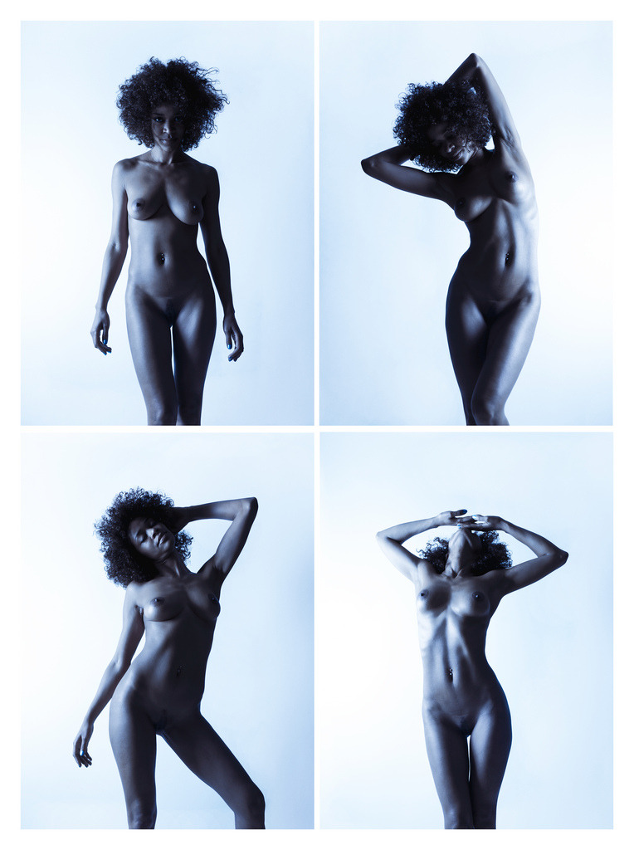

[ big hair four shots.jpg ]

Tell Me All About It - Michael Franks
https://www.youtube.com/watch?v=mjlnwk-7yqM


[ make art.jpg ]
GARY PUCKETT & The UNION GAP - Young Girl / Lady Willpower - stereo
https://www.youtube.com/watch?v=FU8Y5cOIsmE

Have the receiving partner stand against the wall facing out, with one leg firmly planted down and one leg able to move. The penetrating partner then can face the receiving partner, pushing them into the wall (in a consensual, gentle, and sexy way!), and helping their partner's other leg around their back or another surface. Having one leg up and one leg down will allow deeper penetration into the receiving partner, and will maximize sensation for both.

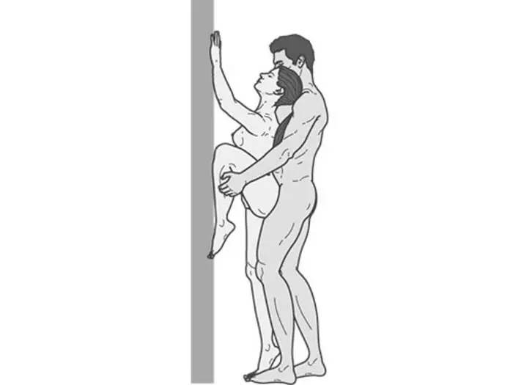
[ standing wall2.webp ]

Almost, but still not quite. You need to be facing parallel with the wall while I lean on you, facing the wall.

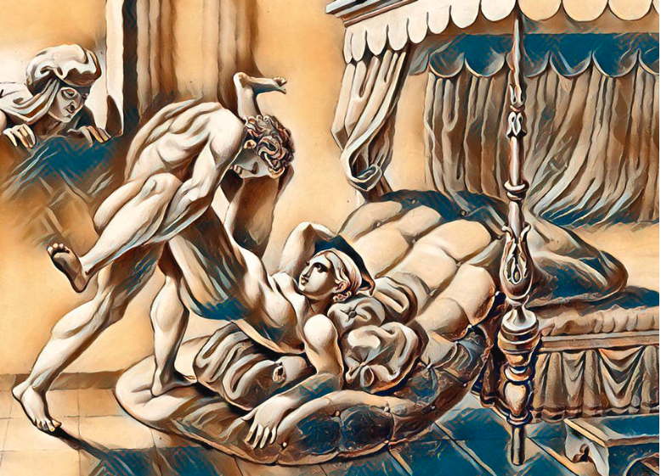

[ abstract three by pd -- fucking and yanking off the bed.png ]
woof!
I'm a country boy from Tappahannock (Ah-woo)

V.A. is where I reside, so shawty understand it (Ah-woo)
And I know I just turned eighteen and I get a little mannish (Ah-woo)

Chris Brown Kiss Kiss (with lyrics)
https://youtu.be/myE9yQF14A0?t=53

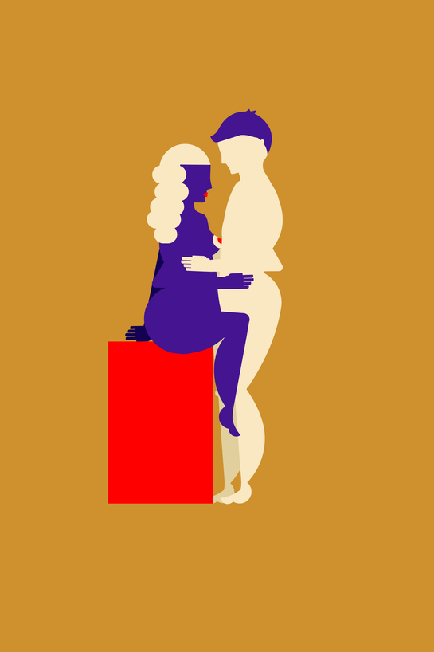

[ fucking on the counter.webp ]

Got me leanin(got me leanin)
Drinkin and driving(drinkin and driving)
Shawty bin feindin(shawty bin feindin)
She say she want me beside her,
but that's a no,no,(no,no)
no I can't do that (why?)
cuz shawty im takin(Shawty im takin)
Just take a sip of dis, drank dat and we'll be hangin swangin,hangin,swangin

T-Pain - Silver And Gold [OFFICIAL SONG WITH LYRICS]
https://youtu.be/6TdhyZ9rBEY?t=71

Side B

That's All by Devin Morrison

https://soundcloud.com/devinmorrison/thats-all

via Soulection Radio Show #415 ft. Devin Morrison https://soundcloud.com/soulection/soulection-radio-show-415-ft-devin-morrison

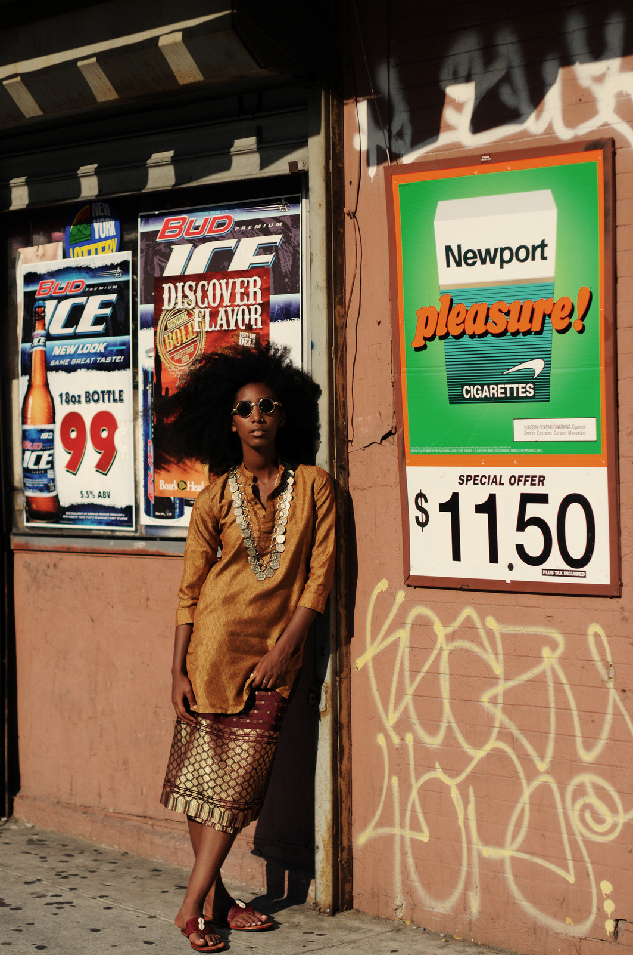

[ dat skirt.jpg ]
That Asian-style skirt
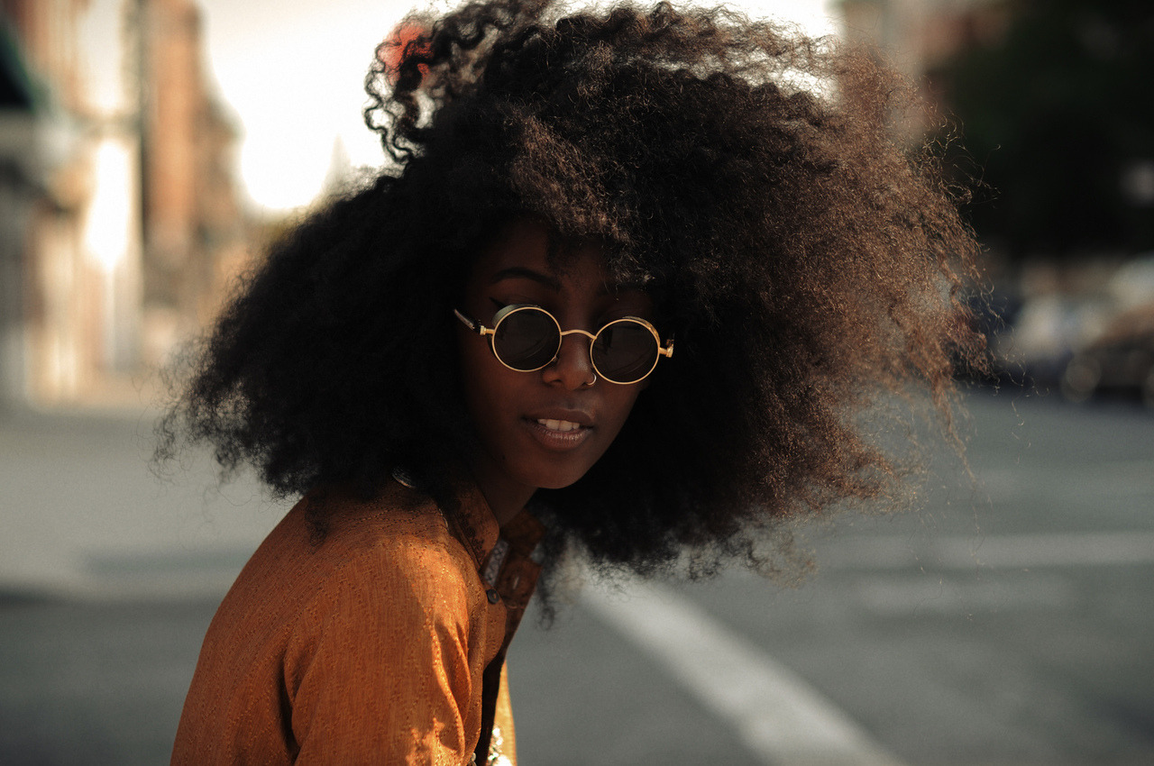

[ fro and glasses.jpg ]
Now she's a very freaky girl..
Don't bring her to mama..
first you get her name..
then you get her number..

Then you get sum brain in the front seat of the hummer..
Then you get sum brain in the front seat of the hummer

Freaky Girl by Gucci Mane
https://www.youtube.com/watch?v=g_aOpa3Pg08



[ long tits poppin pores.jpg ]

Pretty Brown by Amerie ft. Trey Songz
https://www.youtube.com/watch?v=YcshJuTfwJg

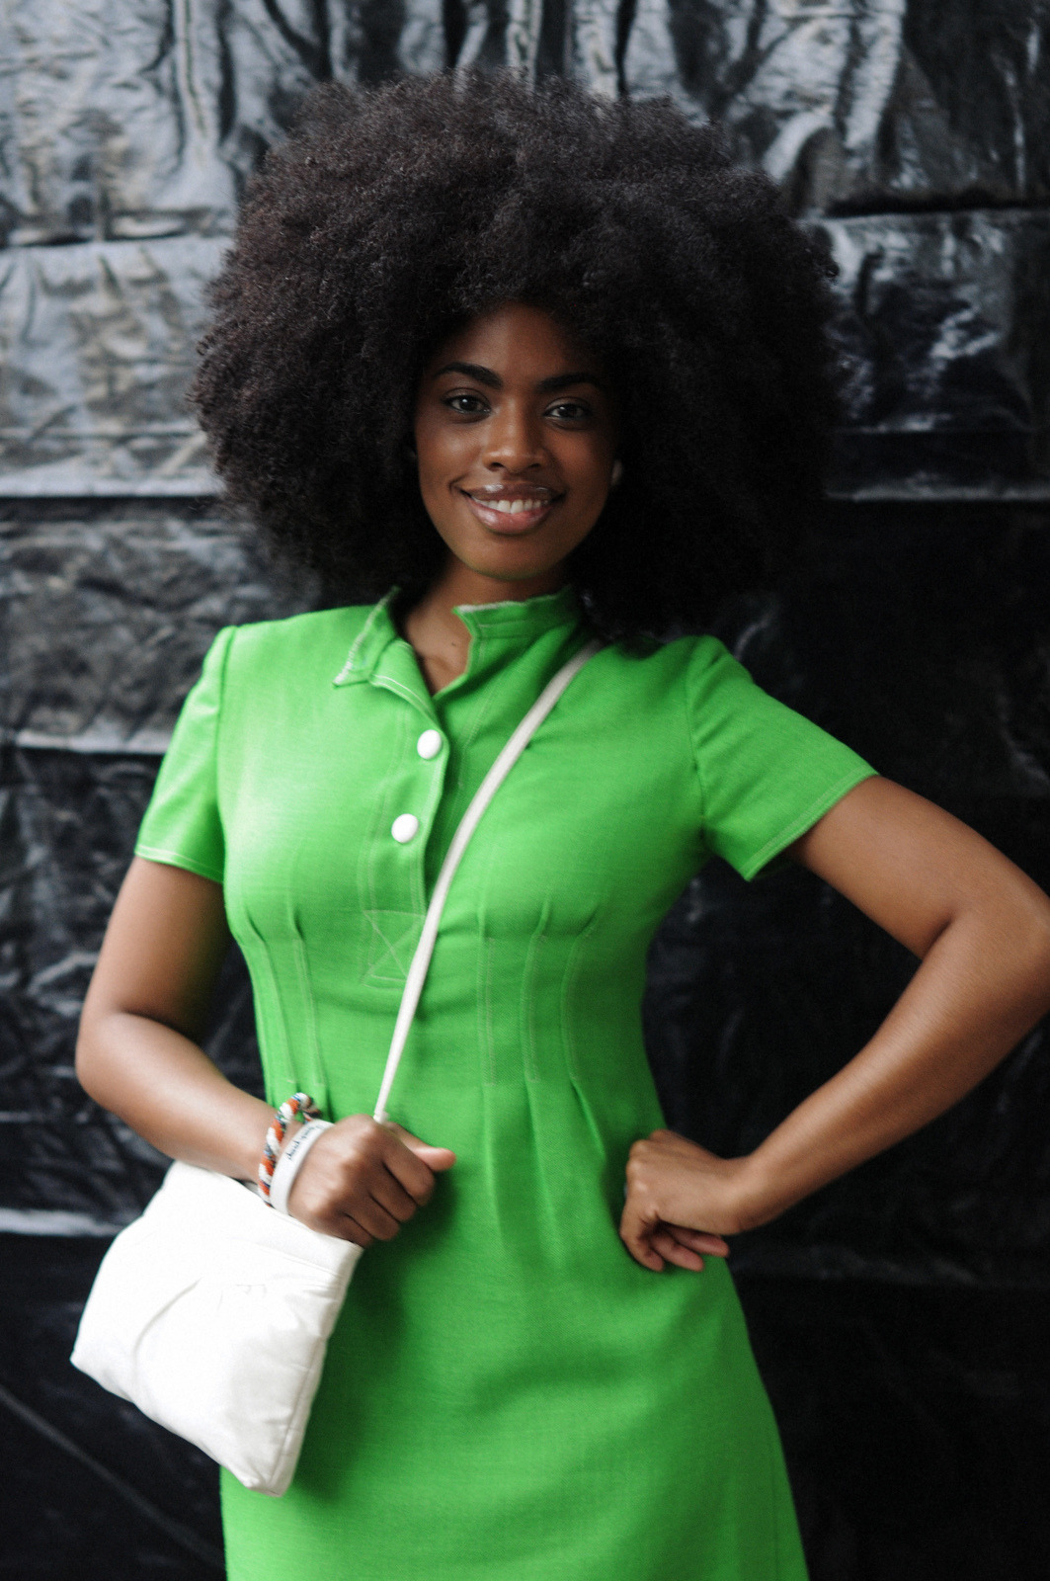

[ confidence.jpg ]

She probably a freak in the sheets
I hope she’s a freak in the sheets...
...like this maybe? :)

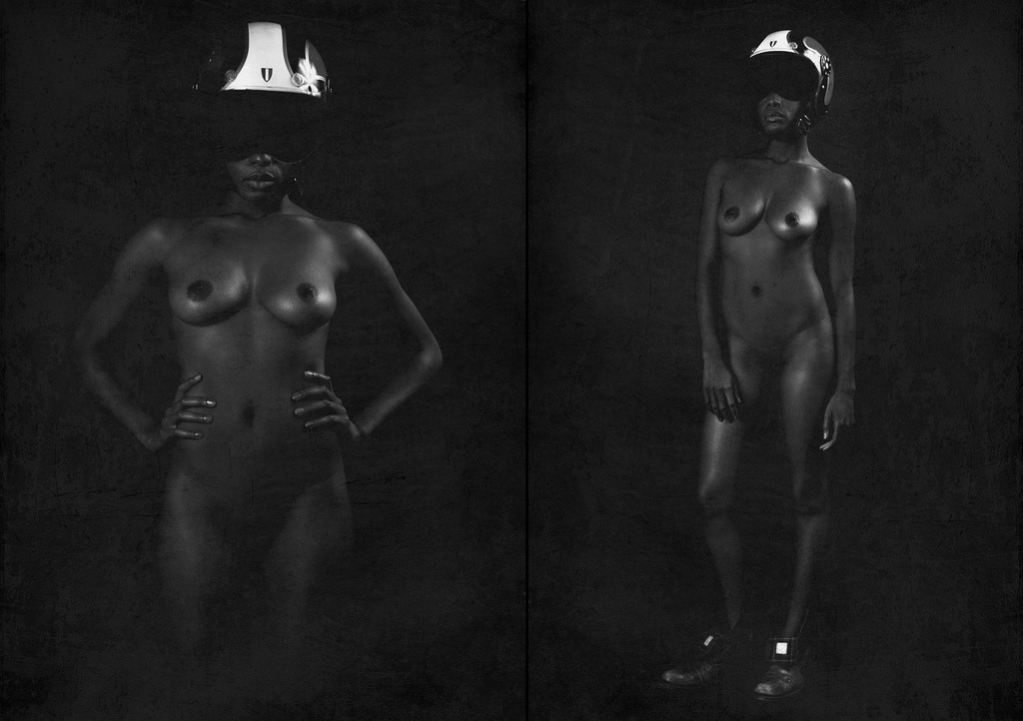
[ nude po po.jpg]

Girl I'm in love with you baby
And I want you to know
That I'm hooked on your body
And I'm trying to be yours
Hear my words for their worth
Ain't just trying to get in your clothes
Ok I'm lying
But damn you fine
And umm!
(She rockin' that thang ) Oh yeah!

The Dream - Rockin That Shit (Love vs Money)
https://youtu.be/lcmheWK5fQw?t=147

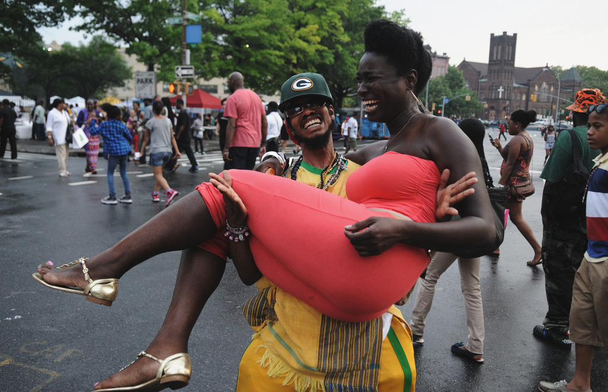
[ ridiculous dude carrying very black girl.jpg ]
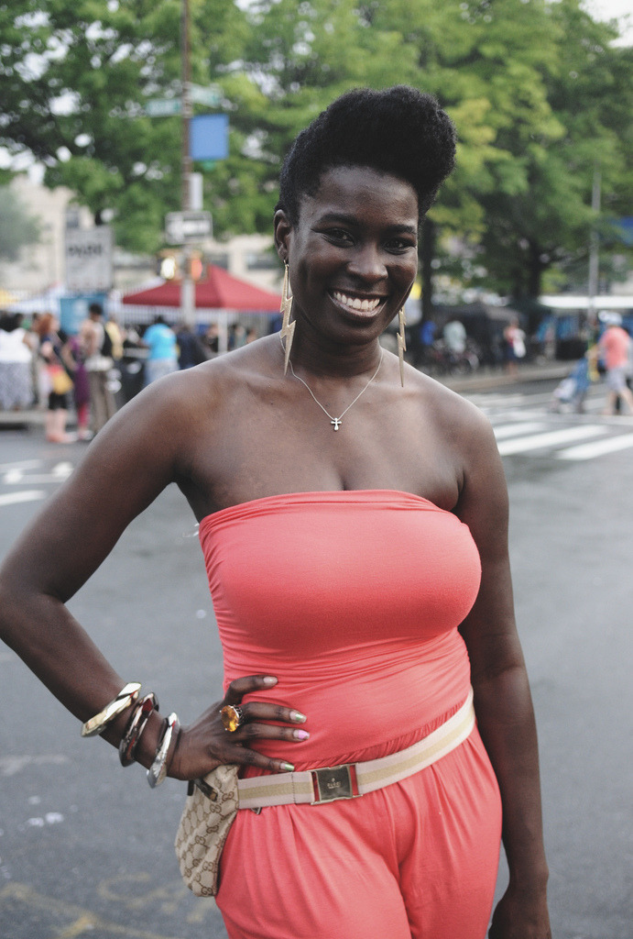

[ handsome ho.jpg ]

Well, aren’t you a handsome ho...😗

D'Angelo - Me & Those Dreaming Eyes Of Mine (Jay Dee Remix)
( or Me And Those Dreamin' Eyes of Mine (J. Dilla Remix) – D'Angelo )
https://youtu.be/I3bTxCriA2Q?t=50



[ black girl with indian style jewelry.jpg ]
Look at that boobage, barely restrained. Uhnn…!
MMYYKK - Na Boca Do Sol [Interpretation] (Self-Produced)
https://soundcloud.com/blackjon66/mmyykk-na-boca-do-sol

What are we doing apart?
Not necessarily physically
But spiritually, aesthetically,...
...Love-actually?

Intellectually…
...I know that no one is an infinite fount
of anything
and still I wanna mine it all:
mine you for YOU;
Take YOU and preserve YOU for the ages.

And you’re allowed to change:
you’re human.

And maybe this spark doesn’t last even 2 more weeks, huh?
And what a 2 weeks it’d be, huh.

Uthando (feat. Nonso Amadi) by GuiltyBeatz
https://www.youtube.com/watch?v=RV39Rb4XosE

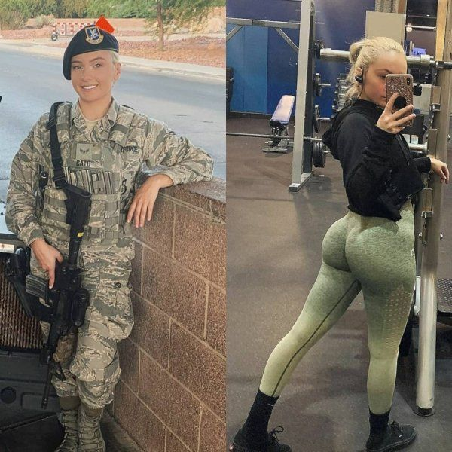

[ dangerous gym bunny.jpg ]

Do you consider yourself dangerous?
Could you be dangerous for the right reason?
For the right person?

AFRO by KAELIN ELLIS
https://soundcloud.com/kaelinellis/afro



[ big hair on a boat (too skinny).jpg ]

Anytime (feat. Kehlani & ROMderful) by Jean Deaux
https://soundcloud.com/thatsjeandeaux/anytime-feat-kehlani-romderful



[ having good time.jpg ]

I hope you’re having a good time...
...but like, can we get to fucking?


[ blue haired between legs frotting.webm ]
I'm coming back for good
So let them niggas know it's mines
Already got someone that's what you tell 'em every time
That shit ain't up for grabs
Where you at on the map
I come to where you at
Fuck around and end up your last
I won't hold back
I won't hold back

It's about time I do it
It's about time I say this shit
Spent a lot of time on the waiting list
Roll up the doja then blaze that shit
Who gonna give you love an insane as this
A-game girl, I bring that shit
$teev - Let Em' Know
https://youtu.be/mqtOVLjfRFE?t=66
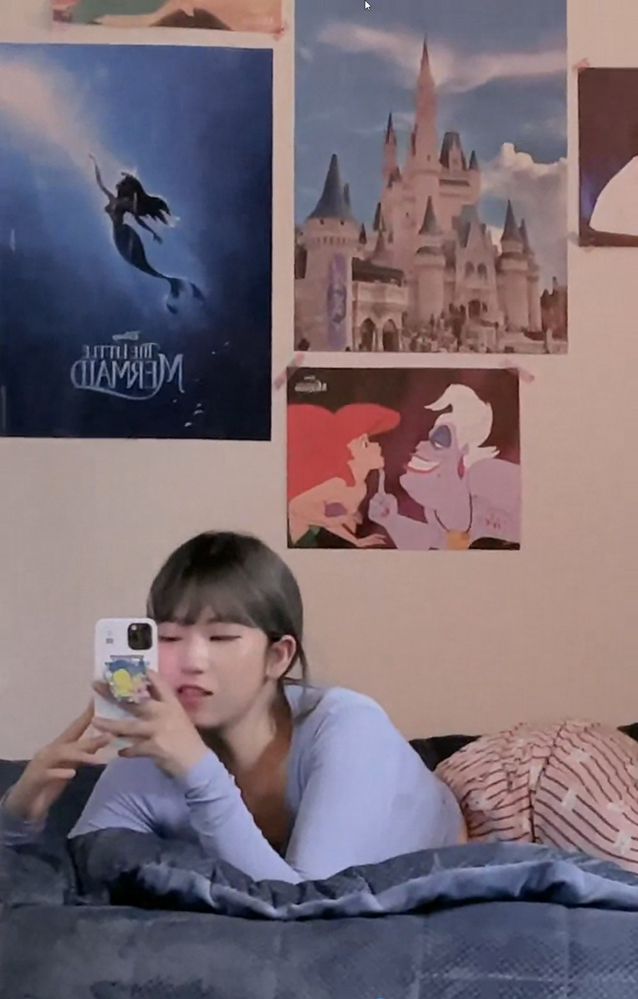

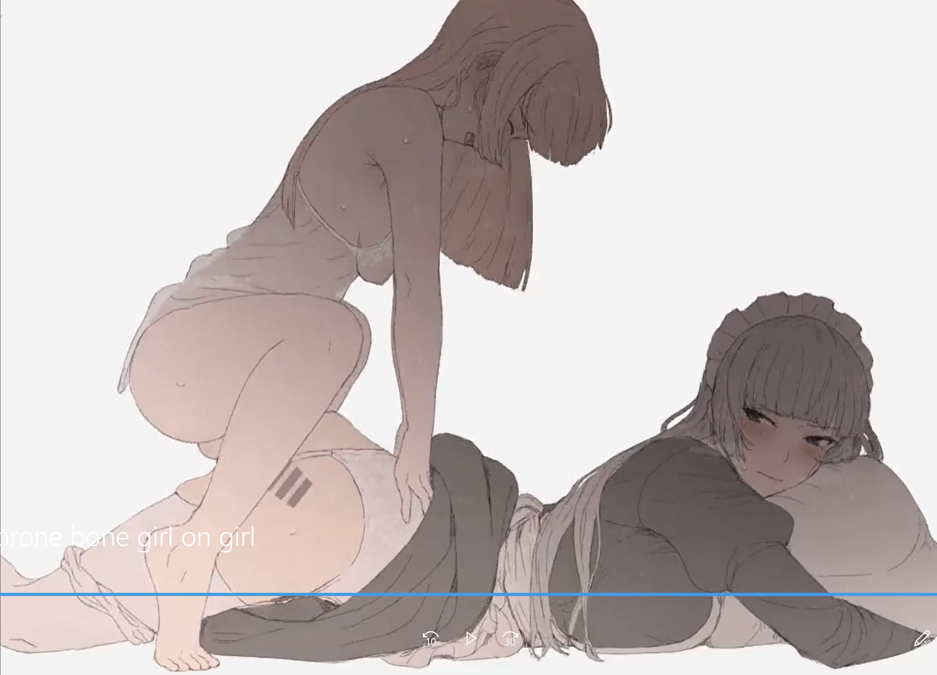

[ heeheemoon-undulating bootywebm.webm ]
[ animated prone bone girl on girl.webm (make it loop) ]

Can I jump on that booty and get it?

Stronger Than Me (Alby D Bootleg)
https://soundcloud.com/albydanielsmusic/stronger-than-me-alby-d-bootleg


[ petting the pussy.webm ]

Stay (feat. Gabzy)
https://soundcloud.com/melvitto/stay-feat-gabzy


[ energetic ride bmwf.webm ]

If it slips out, grab it and put it back!

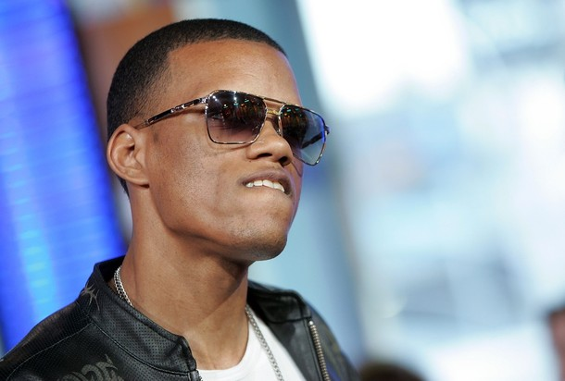

[dat ass meme.jpg]

@1555pm
Owner (feat. AdeJosh, Charlie Mase & Keys The Prince) by OluwaJBeats
https://soundcloud.com/oluwajbeats/owner-feat-adejosh-charlie

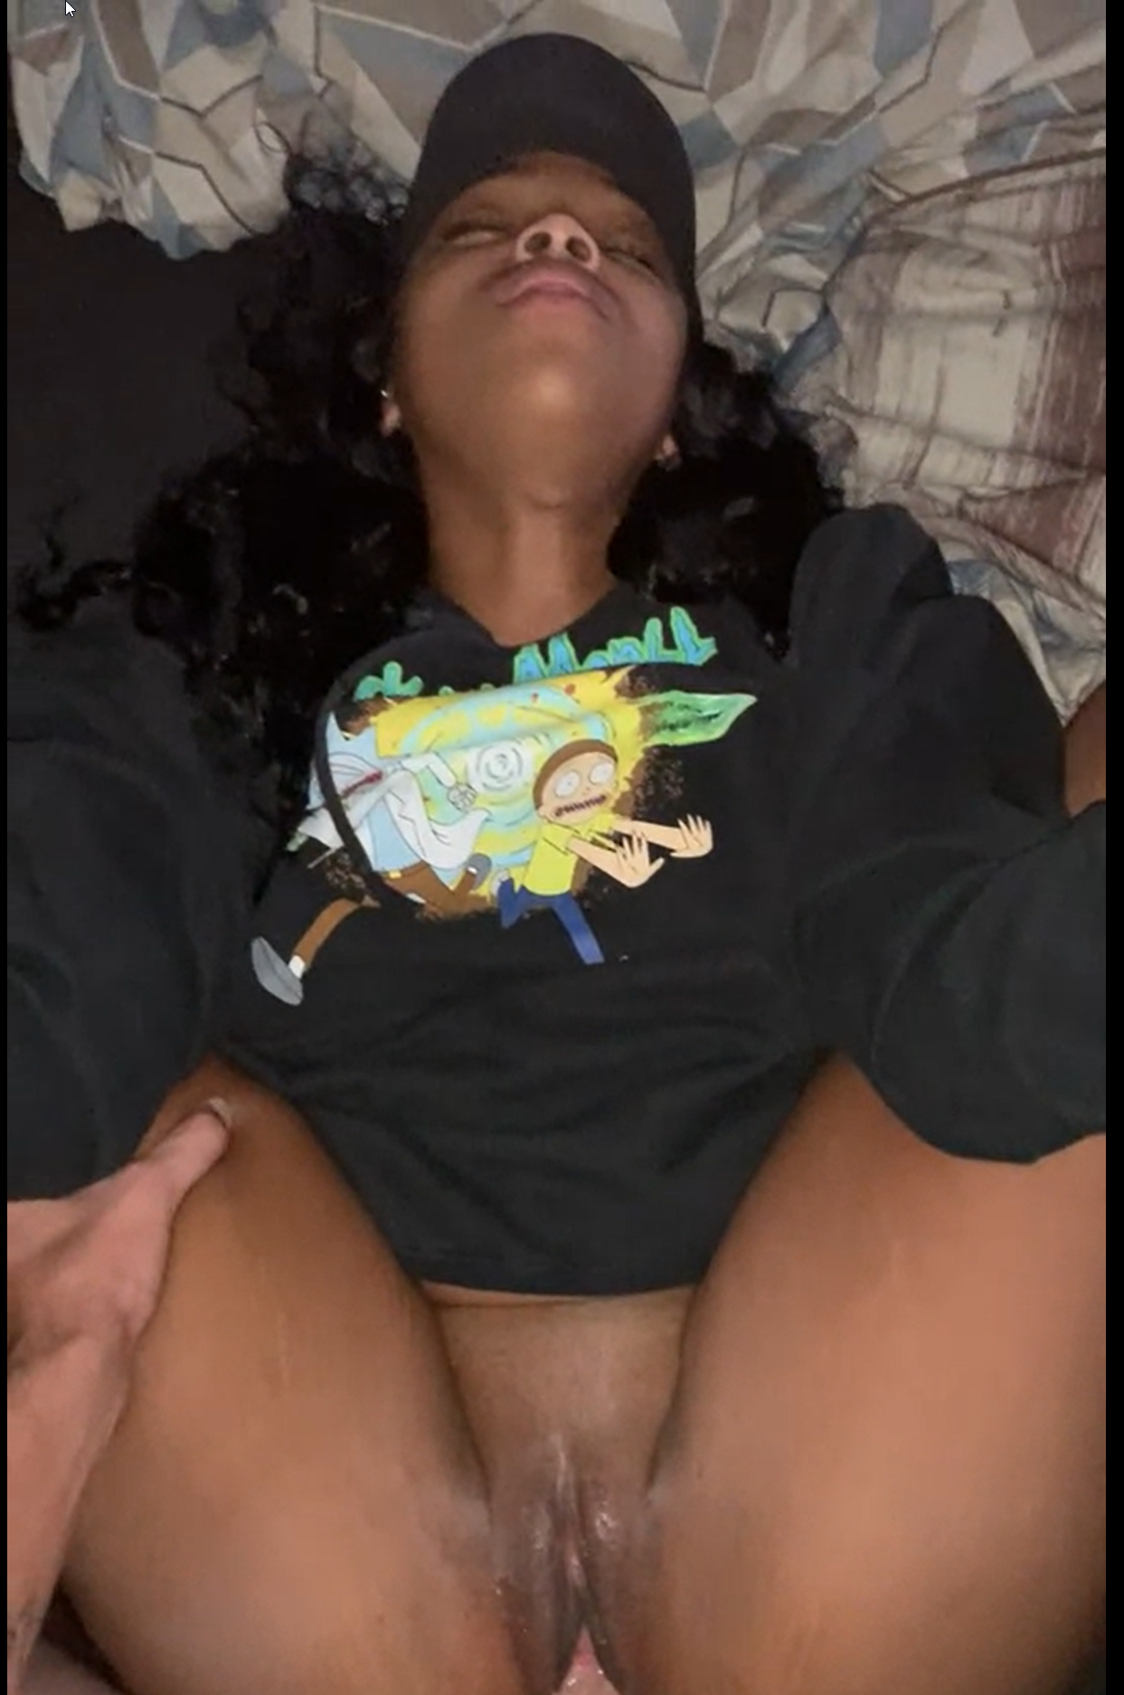
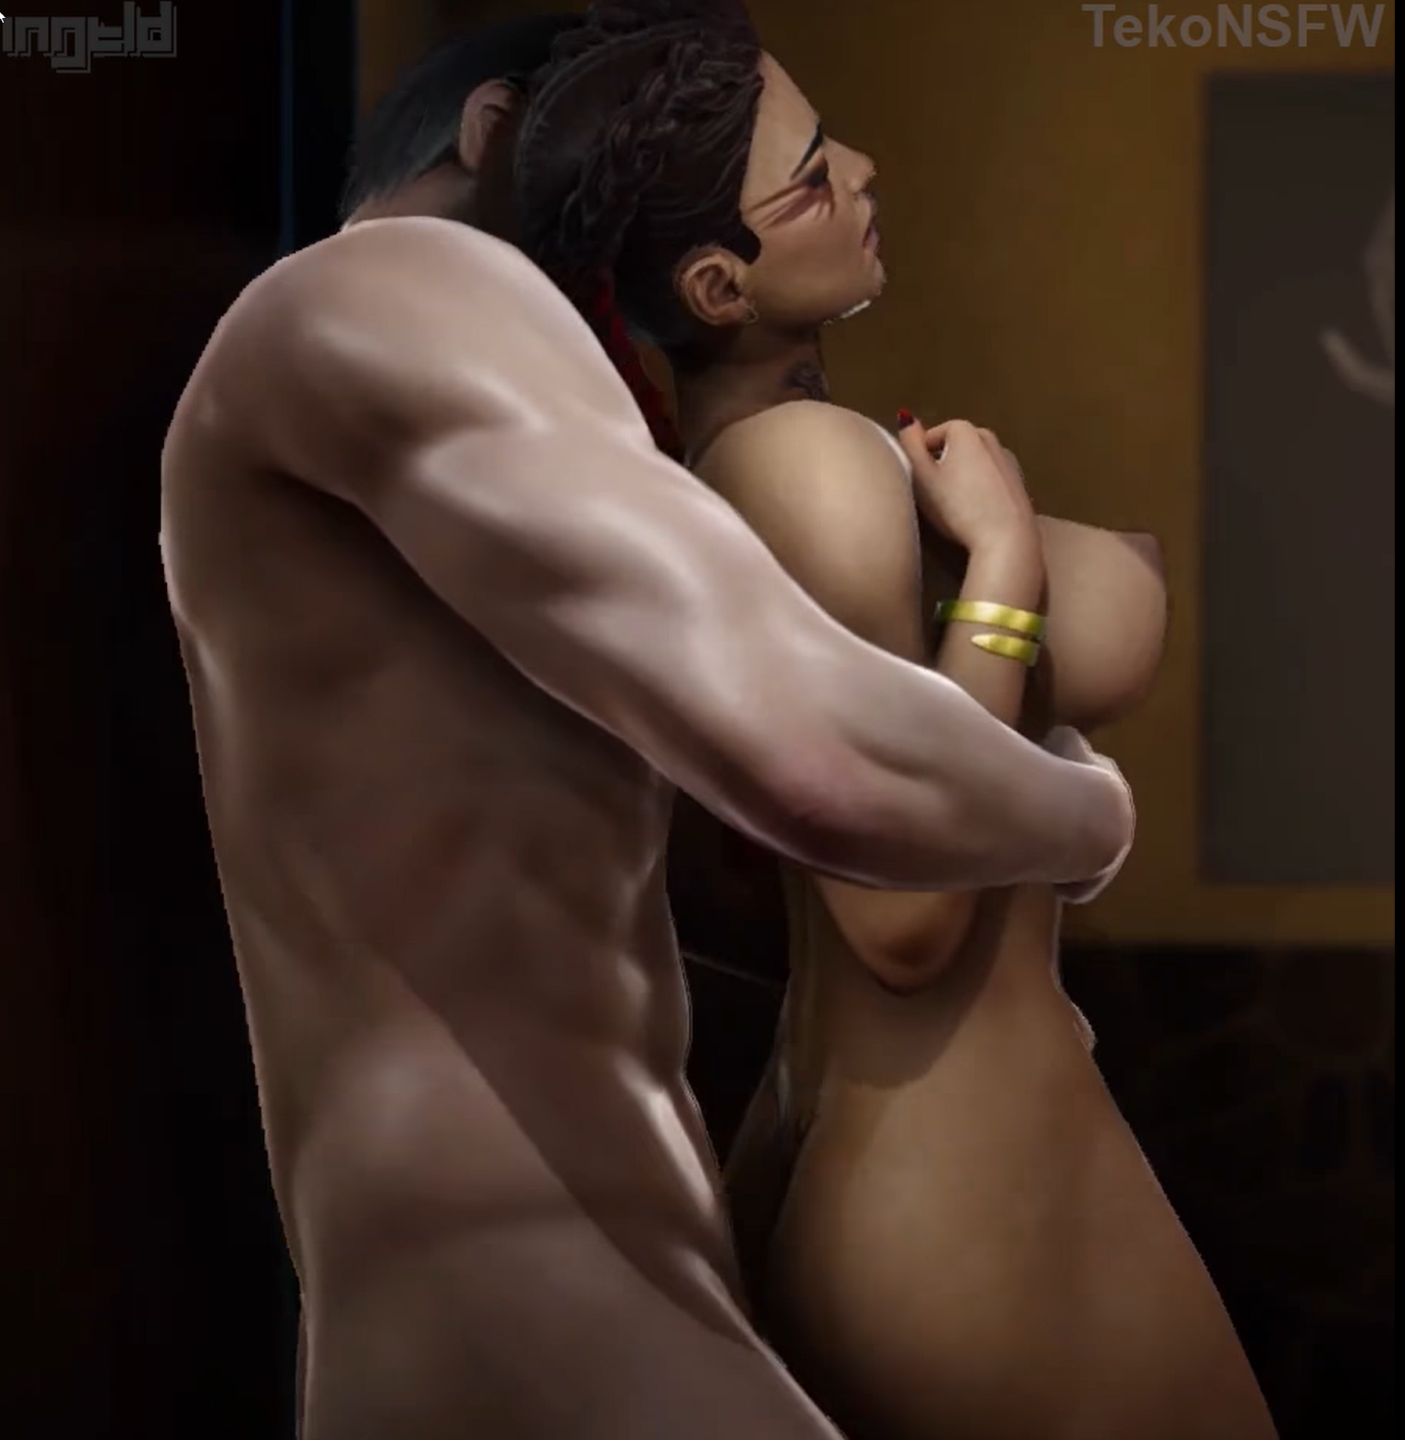

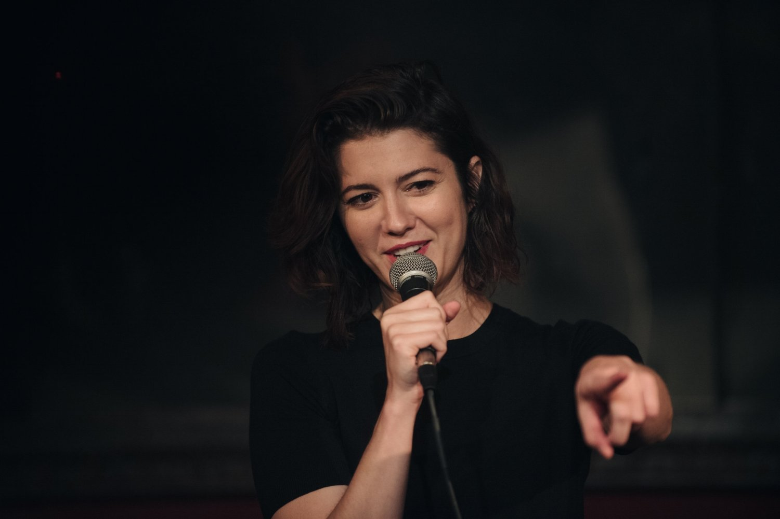

[ like white guys.webm ]
[ rick and morty shirt fucked.webm ]
[ PUTA.jpg ]

Shit girl, I’m flagging...phew!

K, Le Maestro - Dem Boyz (Lab Sounds out NOW on SCM)
https://soundcloud.com/streetcornermusic/k-le-maestro-dem-boyz-lab-sounds-8219-on-scm



[ hard spooning.jpg ]

I may know the answers
Though one question I still hear
What twist of fate has brought us
To roads that run so near?

Distant worlds together,
miracles from realms beyond
The lifelight burns inside me
to sing to you this song
To sing with you this song
To sing to you your song

Memoro De La Stono~distant Worlds (Final Fantasy Xi)
https://youtu.be/FAiFyvro5-4?t=131

[ girls spooning.jpg ]

@1609pm
FIN

Fauré: Cantique de Jean Racine Op 11
https://www.youtube.com/watch?v=NzUMfVpugq4

Gabriel Fauré - Requiem
https://youtu.be/TtJeTMRzn8A?t=1589

Become Ocean by John Luther Adams
https://www.youtube.com/watch?v=dGva1NVWRXk

