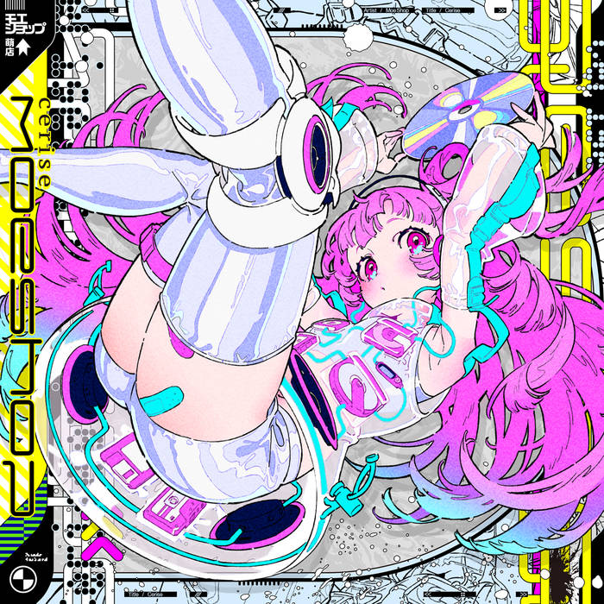

4ameditation
casual games/from behind
2023Jan8@1317pm (Sunday)

CASUAL GAMES
- With A.A., Korean drama and holding hands
- With M., mobile app games like crossstitch (its too bad I see in black-and-white since the game requires matching “stitches” by color)
- With K.C., its music and dancing and fine art
- With C., its also dancing
- With N., its weed
- With S.W., its computers
- With A. nwa M.S., its books
- With M. (S.C.N.), its event planning
- With A.S. (S.M.N.), its her laughter
- With K.S., its also her laughter
- With R, its her docility
- With Z, its chess and moving to music
- With L., its her deep voice and accent and hair and boobs
- With N.Z., its the safety to talk about (almost) anything
- With D., writing
- With S.M., the comfort to talk all night long
- With T.A., its partying

Chill, Sunday music Spotify playlist that is not lo-fi girl
- Doin Fine by Boyz II Men
- Close to you by Bebe and Cece Winans
- Faded pictures by Case and Joe
- Muje by Barry Jhay
- Dumebi by Rema
- Say Aah by Trey songz
- Sponono
- Yapa by Kizz Daniel
- Ijo (Laba Laba) by Crayon
- Big energy by ladipoe
- If you leave by Young Jonn
- We outside by Olamide
- Listen by Basketmouth
- Amorawa by Wande Coal
- Kilofeshe by Zinoleesky
- I feel it coming by The weeknd
or

Taxes
(For soundbar and smartTv)

Visuals
- Ambient swim s1e6 (HBO Max)
- e5
- e1

Audio
- Doin fine – boyz ii men
- Pass you by – boyz ii men
- Close to you – bebe and cece winans
- Tell me its real - Kci and jojo
- Close to you - Bebe and Cece Winans
- Real love – keyondra lockett
- Claustrophobic – pj Morton
- Swv – weak
- Be your girl – teedramoses
- Ill come too – james blake
- Faded pictures – case and joe
- Dumebi – rema
- Amorawa – wande coal
- Ijo (laba laba) - crayon
- If you leave – young jonn
- Sponono – kabza de small
- Lenu – buju feat Burna
- Yapa – kizz Daniel
- Its plenty – burna boy
- Big energy – ladipoe
- We Outside – olamide
- Amorawa - Wande Coal
- DJ Teffler Ice prince ft. Snoop Dogg - Oleku (remix)
  - https://youtu.be/BY2Ax4GWQck?t=3
- Ghana bounce – ajebutter22
- Kilofeshe - Zinoleesky
- I feel it coming - The weeknd

MOE SHOP
https://youtu.be/sWbD5q769Ms?t=122
Moe Shop - Love Taste (w/ Jamie Paige & Shiki)

https://youtu.be/y-27yTRTJtE?t=82
Moe Shop – Cerise

[ OGE: Let’s not close the door, please ]

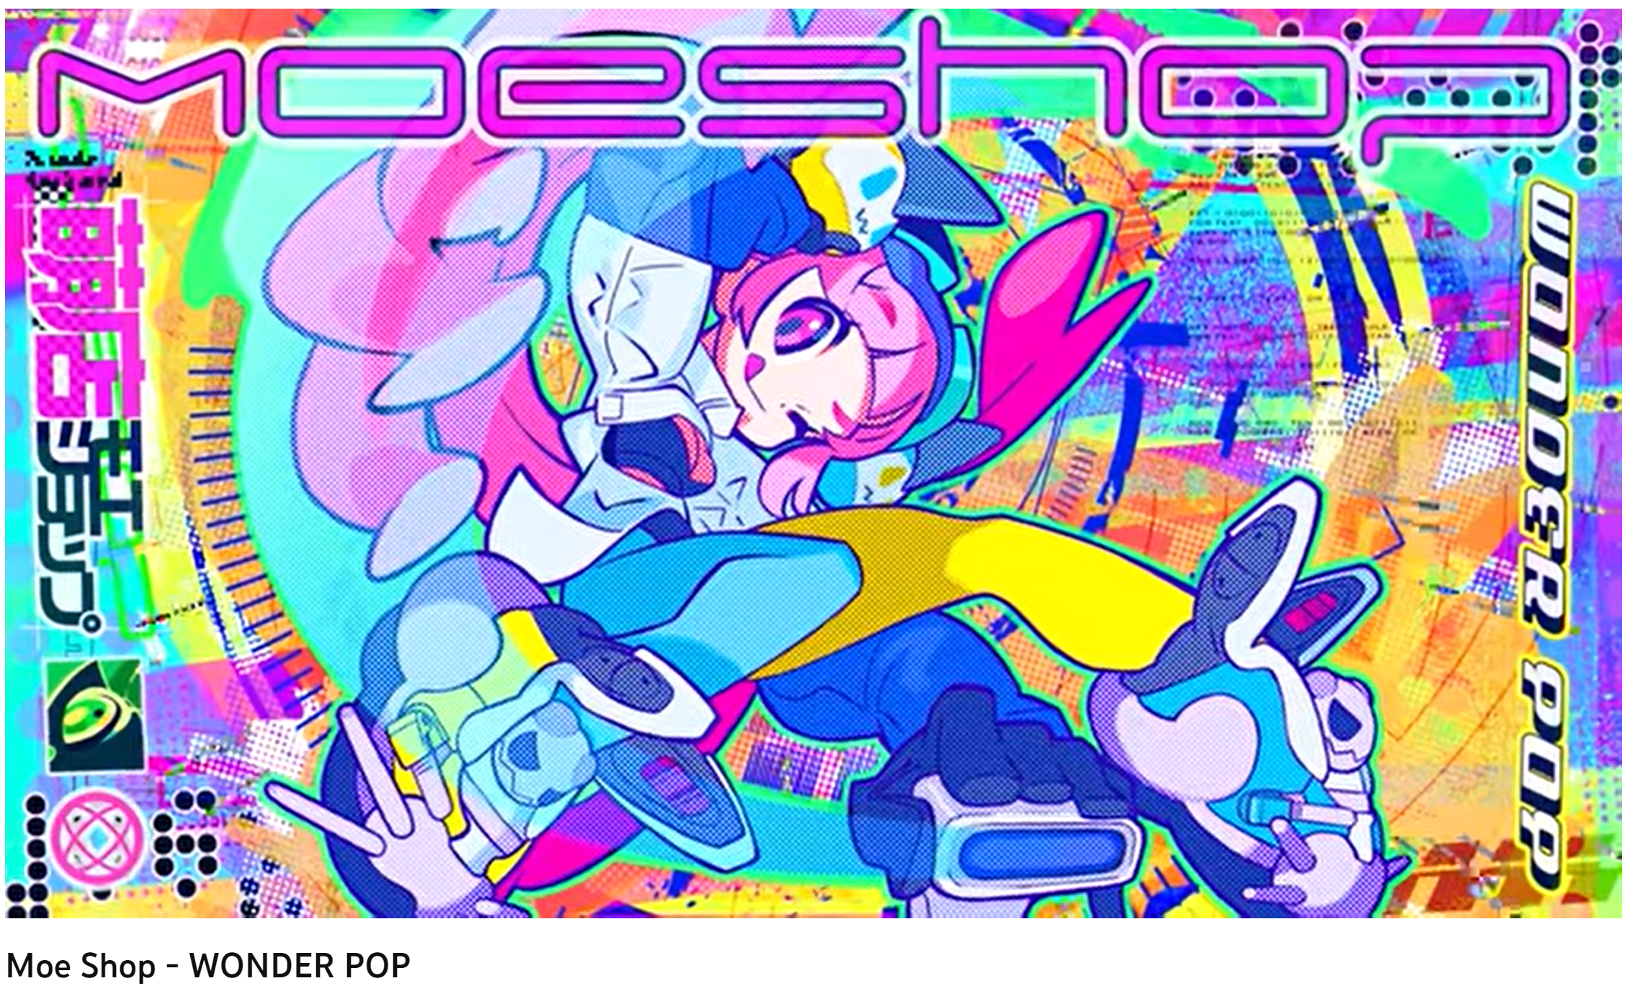
https://www.youtube.com/watch?v=H4PZ7mju5QQ
Moe Shop -- Wonder pop

[ OGE: efiko.png. Look at Shuri and T’Challa’s smiles as they greet each other. Hint: they’re grinning at some shared secret. ]

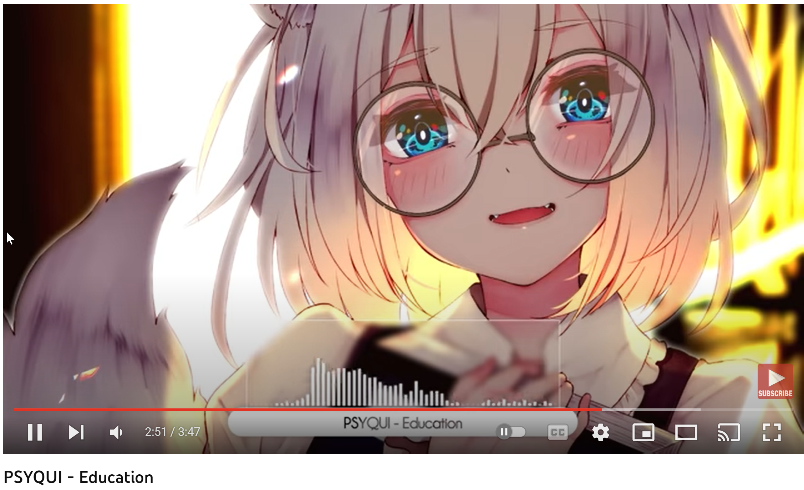
https://youtu.be/IAgTv8b20Dg?t=158
2.Education - PSYQUI

https://www.youtube.com/watch?v=1DlXyONrkjc
@TEEDRAMOSESOfficial - Be Your Girl (Official Music Video)

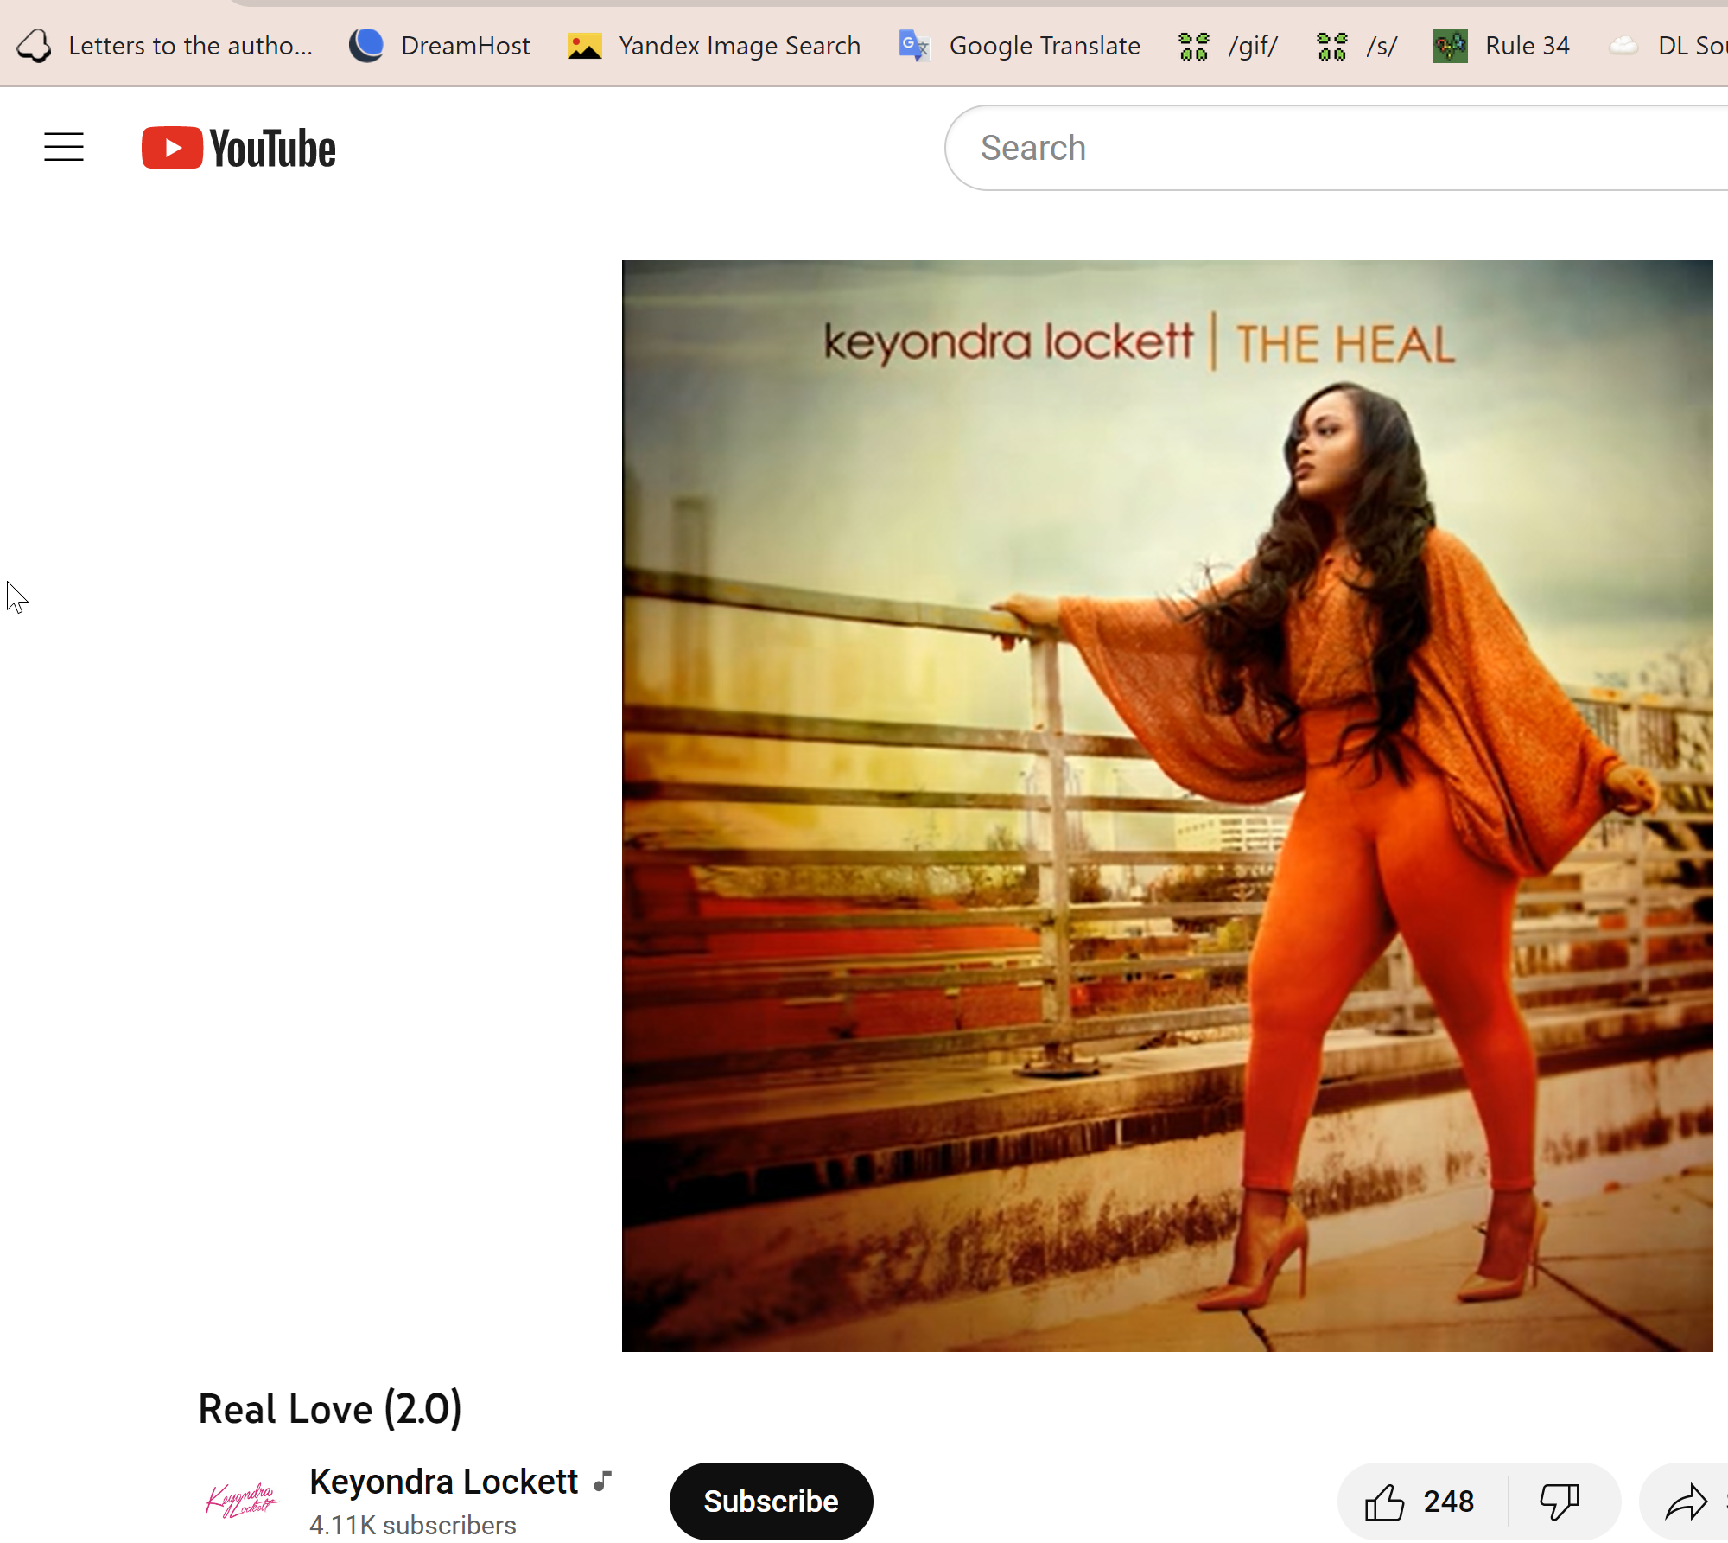

[ OGE: Real love (2.0) by Keyondra Lockett ]

[ jump to Dangelo’s Dreamin eyes for more expressions of longing ]

https://www.youtube.com/watch?v=OHg7Awp-zLQ
Weak by SWV

INTERLUDE A

[ OGE@1716pm: My spotify Favorited songs sound good right about now

Favorited Songs - Jan 2023
- Bounce – Paparazzle
- TIME – Czure
- Organise – Asake
- Available – Korede Bello
- Bandana – Fireboy DML
- Ijo (Laba Laba) – Crayon
- Koo Koo Fun feat. Tiwa Savage) – Major Lazer
- Parcel – Phyno
- Hypertension – Peruzzi
- Levels – Flavour
- Golive – Flavour
- All of Us (Ashawo) – Fireboy DML
- Xtra Cool – Young Jonn
- Squander – Falz
- See Something – Mr Eazi
- AWAY – Oxlade
- Available – LACROWN
- Terminator – Asake
- Abracadabra – Rexxie et al.
- Won Da Mo – Mavins et al.
- Mamela – Mi Casa
- Don’t Forget to Pray – AKA, ANATII
- Real Love (2.0) – Keyondra Lockett
- Do you – Knxwledge
- Imperial – j^p^n
- My kind of love- Conor Albert, Carmody
- Dance with me – sarah kang
- If I’m insecure – James Blake
- Sponono – Kabza de Small
- Ebube – Flavour
- Munachi – Flavour
- Monalisa – Lojay, Sarz
- Machala – Carterefe, Berri-Tiga
- Overloading (OVERDOSE) – Mavins et al.
- SO beautiful – Timi Dakolo, Elvis Larri
- Do Me Nice – Show Dem Camp, BNXN fka Buju
- In your arms – Saib
- Ryde – Niniola
- 24’s – Richgirl, Bun B
- Words that we couldn’t say – Steve Conte
- Malka Moma Si Se Bogu... – Philip Koutev National Ensemble
- Billionaire - Sunday Okorie ]

JP by Jesse Powell (album)
https://en.wikipedia.org/wiki/JP_(album)
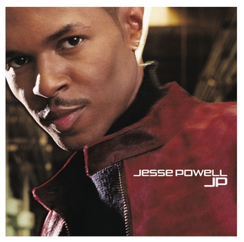

It will take the world and so much more
To take your love from me
And even when it wouldn't be enough
Because you're the world
Can't you see, to me

https://www.youtube.com/watch?v=pDXo4_ehRzc&list=PL2iM7JvGrAzraqxdL5Ej-pdvJ0IoZ5S_J&index=1
It’ll take the world

Oh I know
I know I was wrong
With you I belong
If our love is gone
How can i carry on ?
I'm so alone with out u to hold
Won't you come home

https://youtu.be/4juoPhg2Q8s?t=167
If I

I know you're thinking you're the bomb and your game is tight
And usually I'd give you props, but not tonight
And I know you're thinking this really don't concern me
But I'll tell you what, you're messing with my family
At the club, at the show, at the mall, we know
The look on your face said it all
Raising your voice ain't something you wanna do
But we can take it there, girl, if you want to

https://youtu.be/_smDeBAQuv0?t=67
I'm Leaving

You had the longest day
For whatever reason and I
I understand so let's kiss
And let's hug and let's touch
Like only we can

https://youtu.be/jsbbhEs18Dk?t=50
Go Upstairs

Please pack your bags
and come on back
cuz now I realize that I’m in love with
you.

https://youtu.be/7TbvhcucN0M?t=233
I Didn't Realize

Here I stand, the invisible man
You don't even see
What you do me oh
Don't you see me standing here
Or have I disappeared?
I might as well not even be here.....at all

https://youtu.be/UYDqvyYuGDE?t=52
Invisible Man

Interlude B

Sasha Marie Radio Chapter #76 https://soundcloud.com/sashamarieradio/chapter-76

[ slideshow of all the pictures and videos in the directory: from-behind ]

[ OGE: itll happen to you.jpg. LOL ]

Chaines Turns a la ballet

Know you know you got it bad when you're stuck in the house
You don't wanna have fun, it's all you think about
You got it bad when you're out with someone
But you keep on thinking 'bout somebody else

https://youtu.be/o3IWTfcks4k
U got it bad by Usher

Even though I love her so
She got love for me
But she still belongs to someone else
And I wish I never met her at all

https://youtu.be/9fQwrkTktug?t=163
Carl Thomas - I Wish (Official Music Video)

Touching you, holding you
Is all I really wanna do
Day and night I just can't get enough

https://youtu.be/VFNtwDEFkwY?t=55
Giving You All My Love

It was cold the way you left
Still the pain is in my chest
Because in my heart I felt you should've came and talked to me
If you put away your pride
And look deep into my eyes
It would've been to your surprise
That I got up to apologize
But you were gone

https://youtu.be/YS_DNFMlB8k
Woke up in the Morning by Carl Thomas

No notice, no letter, you just packed your shit and left
Girl, I deserved better, I treated you like no one else
How could you? You know I loved you and I thought this love was true
Now we're through, what I'm gonna do?
Gotta start a new life without you
Now we're through, what to do?
Gotta start a new life without you

https://youtu.be/8JRhmbYV9n4?t=150
Bilal - When Will You Call

As we stare from across the room
Starting to ponder what we've been going through
What does my kiss mean to you?
Are we just friends or is this more to you?

But if we label this, just picture what we might lose

https://youtu.be/ATy3-_Iwo5U
Love Poems by Bilal

Is it just that you're the finest little thing that I ever saw
Or is my imagination runnin' too far
Or is it that my eyes are tellin' me something you could never see
Somethin' like me being with you
and you being with me

Ooh-wee baby you've redefined my vision of love it seems
Your love be the cherry in my chocolate covered dreams
So it seems my oh my
Me and those dreamin' eyes of mine (oh)

https://youtu.be/GqUUFuxpiSk?t=65
Me And Those Dreamin' Eyes Of Mine by Bilal

When we get by, we'll make it by, when we get by with love
I look in your eyes, I look in your eyes
They're pretty as the skies above

https://www.youtube.com/watch?v=bQljCHQudM4&list=PLj0iicDFTqJr8--ztYXoBDcVfOYIGSoZr&index=8
When We Get By by D’angelo

FIN
@0835am the next day
- Scape goat by dbanj
- Mama by kizz Daniel
- Lol :-) by trey songz
- The best by davido
- Tanana by davido
- Common person by burna boy
- Vanilla burna boy
- Last last by burna boy
- It’s plenty by burna boy
- Mebe by davido
- La la by davido
- The best by davido

[
@2306pm:

https://youtu.be/QOWepkAK5FA?t=673
Cowboy Bebop Remixes: Music for freelance (album)
]

