
Porn and poetry


2023Jan9@1721pm

Sexy Movies
- The Lover (1992)
- Legend of 1900 (1998)
- Love (2015)
- Blue is the warmest color (2013)
- Nymphomaniac (2013)
- The piano teacher (2001)
- The Dreamers (2003)
- y tu mama tambien (2001)
- Eyes Wide Shut (1999)
- the reader (2008)

[ annotated with the most touching scenes I remember ]

The Written Word
Its a good story. About a boy lusting after his after-school teacher. Then one day his grades stop improving and she promises him pussy if he comes first in class (tee-hee).

And that scene where they’re having sex in the cinema, and some rando kinna joins them without their noticing: priceless 😂

https://www.hentairules.net/galleries10/index.php?/category/394
- KayaNetori
  - https://www.hentairules.net/galleries10/index.php?/category/394
- And what of the story from “sadly porn” by Edward Teach?
  - ch. 8 “My Husband And His Rival Bet Who Was The Better Man-- And I Won”
  - https://libgen.rs/search.php?req=sadly+porn
- And the stories from slow-burn smut
  - [ slow-burn-smut.pdf ]

- Melancholia by Musashimaru is a sweet story of a girl helping out the men of the family at a funeral
  - https://comics.8muses.com/comics/album/Fakku-Comics/Musashimaru/Melancholia

- The final scene of her face in this doujin and the words, “I love Summer”
  - https://hentaiporns.net/c99-saint-seiya-saint-shiro-hamabe-no-doutei-kari-seijo-the-beachs-virgin-hunting-saint-fate-grand-order-english-doujins-com/


- That scene where he thinks he can slip away but she holds onto him…
  - https://doujins.com/hololive/hikoushiki-a-book-about-waking-captain-marine-up-in-the-morning-60988#
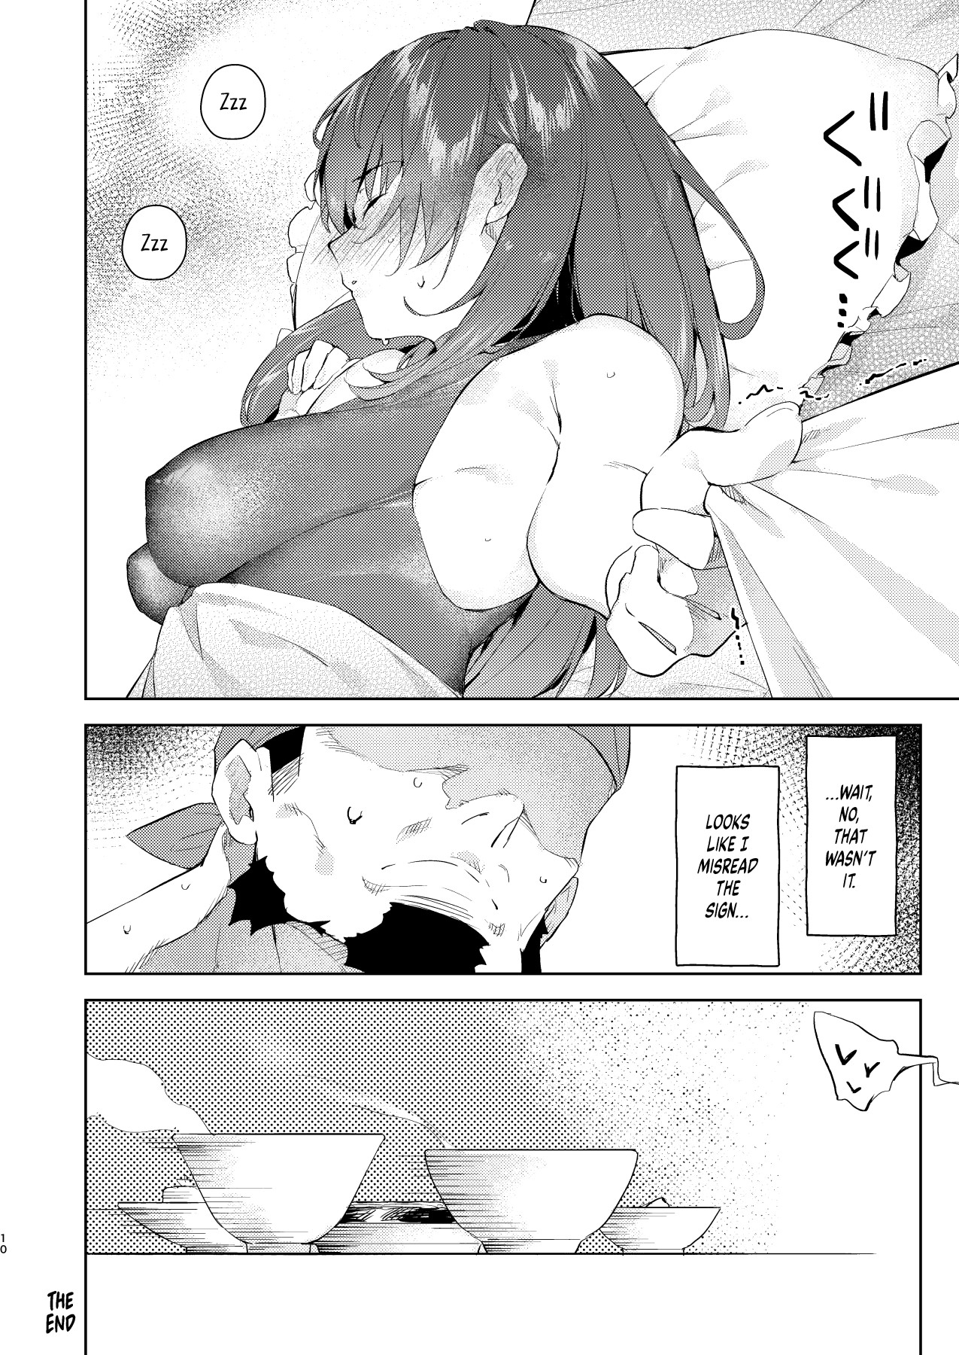

And this is pure fantasy: a woman whose job it is to pleasure you in any way. Sounds like a full-time prostitute.Hmmm….
  - https://www.hentairules.net/galleries11/index.php?/category/500

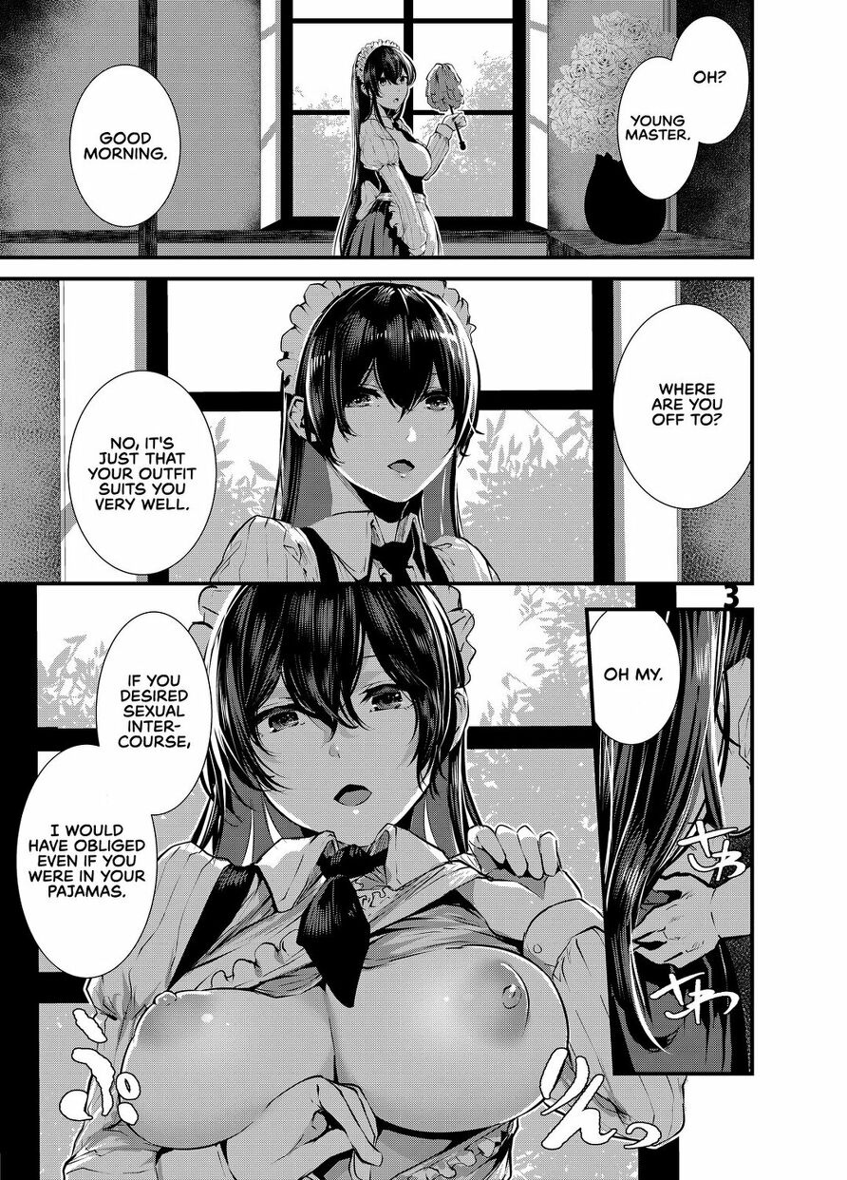

Greentext
4chan greentext is its own thing. To get you in the genre let’s start with some funny ones:
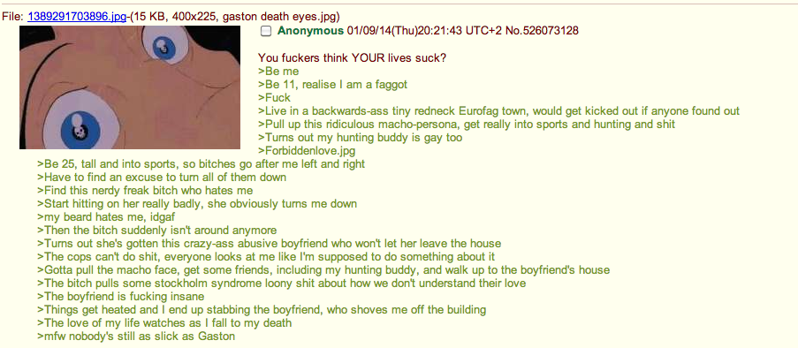

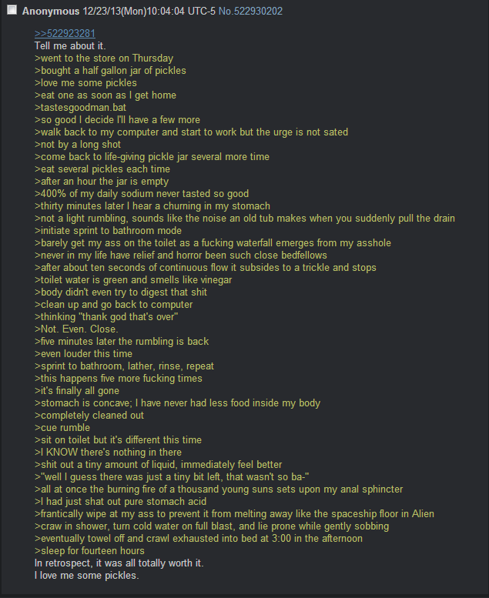

This is pure porn, not real at all, but my oh my...your gf gets you another girl for a threesome? Heaven.

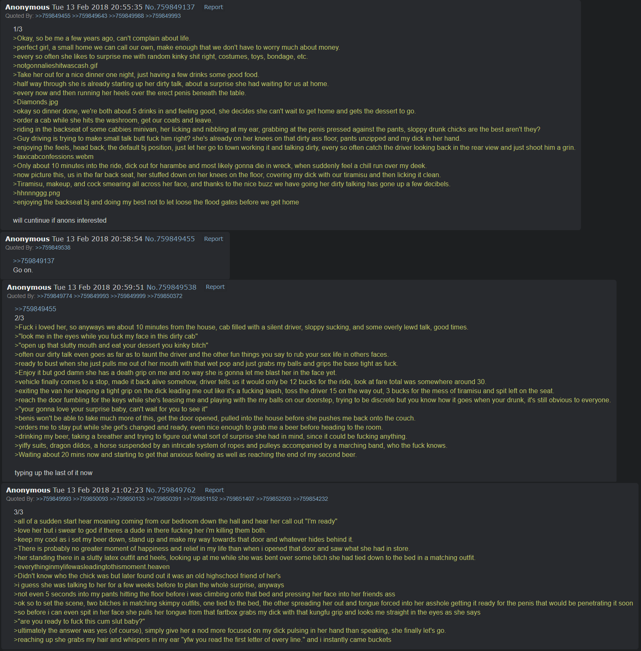

https://www.reddit.com/r/greentext/comments/107o0ki/anon_is_socialy_awkward/



Let’s get some music in here

Luvsic hexalogy by Nujabes
https://youtu.be/wGfguhnvECc?t=299

Pr0jxt-Xp01 by Kendall tisinger x Nez
https://www.youtube.com/watch?v=x_3TnWjEvh4

Ride On Time By Tatsuro Yamashita
https://www.youtube.com/watch?v=g7REbdgOZf0

see the kinna related webm [ ride on time.webm ]. I like planes doing cool things.


Pete Rock & InI - Grown Man Sport (HD)
https://www.youtube.com/watch?v=d9LhFN3H20M



Skating videos are cool too [ oof.webm ]. This video almost seems staged.

Check out this next one: one of my earliest memories.

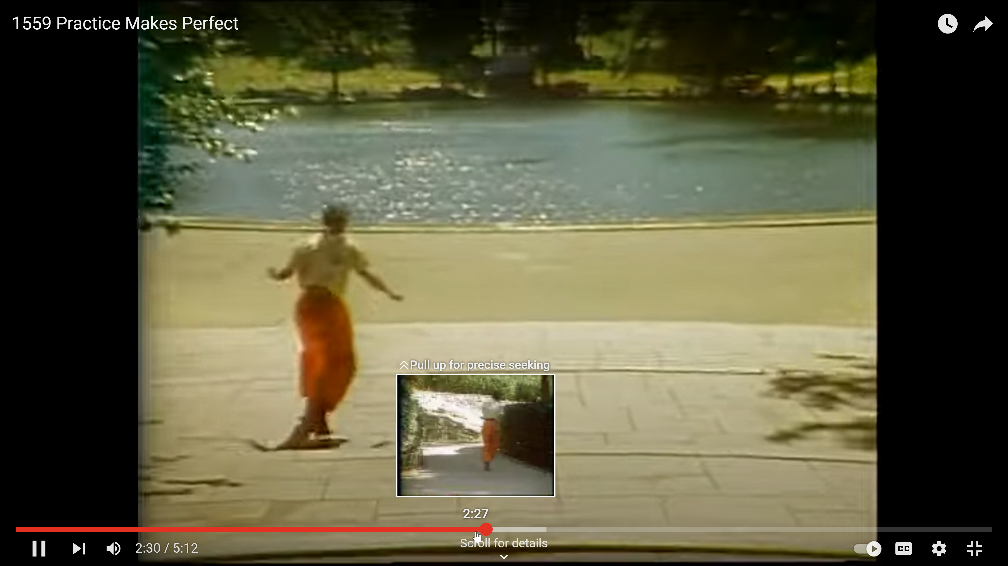
1559 Practice Makes Perfect (sesame street)
https://www.youtube.com/watch?v=ktrfkeX-zfg



[ cars and cool music.webm ]
Cars doing cool shit, too: so cool. Can’t find the original song of this video.
This one’s random cuz I overheard it while stopped at a light. That feel when he tries to do something nice for his girl but she’s too busy and tells him not to bug her.

Gal Ban Jae (Official Video)| Ammy Virk |Avvy Sra |Happy Raikoti |Amanninder Singh |New Punjabi Song
https://youtu.be/A1KjEYwQhdM?t=75

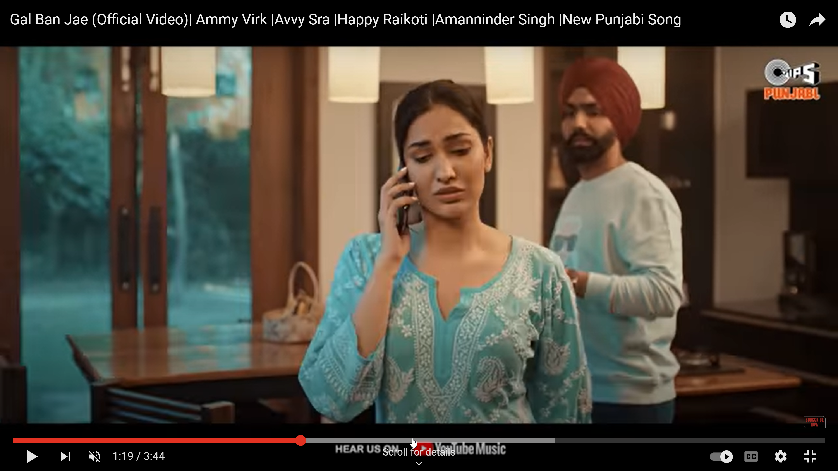
@1058pm
I’m tired and my fingers are sore. Gonna call it a night.

Thanks for hanging out.

FIN

Soulection Radio Show #571 (Nov 4, 2022)
https://soulection.com/tracklists/571

