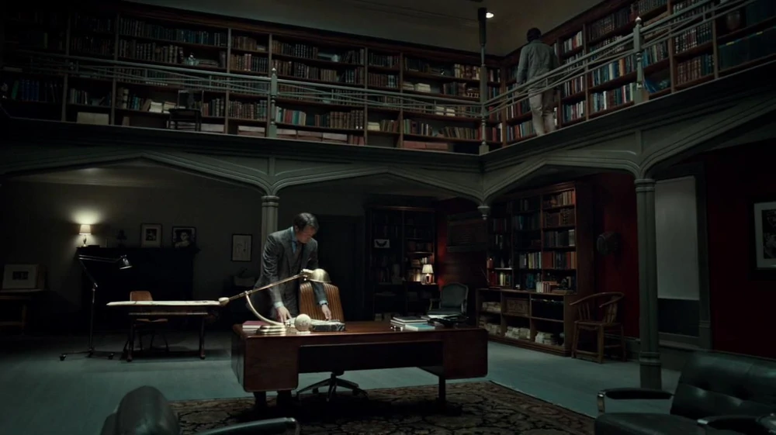


Vampires, and serial killers, and children oh my!
2023Jan14@0818am

A vampire is a mythical creature that subsists by feeding on the vital essence (generally in the form of blood) of the living.
https://en.wikipedia.org/wiki/Vampire

A serial killer is typically a person who murders three or more persons,[1] with the murders taking place over more than a month and including a significant period of time between them.

https://en.wikipedia.org/wiki/Serial_killer

https://www.youtube.com/watch?v=Tf6TSGPvrmg
Hearts soothed by this Soul playlist..💙 Top Hit Soul Songs - Best Soul / R&B mix

Tracklist🤍
00:00 Favorite book - Srah Kang ←--- money
03:28 Rose petals - Revel Day
07:13 You're Sorry - Victor Lundberg
12:38 Lose - R.A.D
17:01 Upgrade - Spring Gang
20:10 For a summer - Sarah Kang
23:14 My caffeine - Faith Richards
26:43 Landfall - Stonekeepers
30:51 And then i wake up - Spring Gang
34:23 Castaway - Lightboys
37:22 High time - Vividry
40:48 I'll Be Missing Your Love - Stonekeepers
45:13 The Other Half - Victor Lundberg
49:03 I Wanna Go Down - R.A.D
52:29 Anywhere - Lightmuzik
54:59 Dance with me - Sarah Kang ←-- money
57:33 Better Place - Spring Gang
01:00:39 Afraid - Gloria Tells
01:03:43 Sweet time - Aaron Kellim
01:06:56 Be mine - Chaun Davis
01:10:34 Falling - Hot Rod Elegants
01:13:57 What I Would Do - Dayon
01:17:48 Right There - Spring Gang
01:21:14 Your Brokenness - Roots and Recognition
01:24:26 Change ft chris hatfield - Ryan Prewett
01:28:21 Bad advice - Casey Parnell

Sadistic personality disorder was a personality disorder defined by a pervasive pattern of sadistic and cruel behavior. People with this disorder were thought to have desired to control others. It was believed they accomplish this through the use of physical or emotional violence.

https://en.wikipedia.org/wiki/Sadistic_personality_disorder

To enlighten mankind and improve its morals is the only lesson which we offer in this story. In reading it, may the world discover how great is the peril which follows the footsteps of those who will stop at nothing to satisfy their desires.

-- Marquis de Sade in "Eugénie de Franval"

New Study Reveals Most Children Unrepentant Sociopaths
https://www.theonion.com/new-study-reveals-most-children-unrepentant-sociopaths-1819571187

Anton LaVey, who has been referred to as "The Father of Satanism",[107] synthesized his religion through the establishment of the Church of Satan in 1966 and the publication of The Satanic Bible in 1969. LaVey's teachings promoted "indulgence", "vital existence", "undefiled wisdom", "kindness to those who deserve it", "responsibility to the responsible", and an "eye for an eye" code of ethics, while shunning "abstinence" based on guilt, "spirituality", "unconditional love", "pacifism", "equality", "herd mentality", and "scapegoating".

https://en.wikipedia.org/wiki/Satanism#Church_of_Satan

Juliette is a novel written by the Marquis de Sade and published 1797–1801, accompanying Sade's 1797 version of his novel Justine. While Justine, Juliette's sister, was a virtuous woman who consequently encountered nothing but despair and abuse, Juliette is an amoral nymphomaniac murderer who is successful and happy...As many other of his works, Juliette follows a pattern of violently pornographic scenes followed by long treatises on a broad range of philosophical topics, including theology, morality, aesthetics, naturalism and also Sade's dark, fatalistic view of world metaphysics.

https://en.wikipedia.org/wiki/Juliette_(novel)

Narcissism is a self-centered personality style characterized as having an excessive interest in one's physical appearance or image and an excessive preoccupation with one's own needs, often at the expense of others.

Narcissistic parents often see their children as extensions of themselves, and encourage the children to act in ways that support the parents' emotional and self-esteem needs. To meet the parents’ needs, the child may sacrifice their own wants and feelings...In extreme situations, this parenting style can result in estranged relationships with the children, coupled with feelings of resentment, and in some cases, self-destructive tendencies.

There is a compulsion of some professionals to constantly assert their competence, even when they are wrong... "Most professionals work on cultivating a self that exudes authority, control, knowledge, competence and respectability. It's the narcissist in us all—we dread appearing stupid or incompetent."

https://en.wikipedia.org/wiki/Narcissism

The dark triad is a psychological theory of personality, first published by Delroy L. Paulhus and Kevin M. Williams in 2002,[1] that describes three notably offensive, but non-pathological personality types: Machiavellianism, sub-clinical narcissism, and sub-clinical psychopathy.

- Narcissism is characterized by grandiosity, pride, egotism, and a lack of empathy.[10]
- Machiavellianism is characterized by manipulation and exploitation of others, an absence of morality, unemotional callousness, and a higher level of self-interest.[11]
- Psychopathy is characterized by continuous antisocial behavior, impulsivity, selfishness, callous and unemotional traits (CU),[12] and remorselessness.[13]

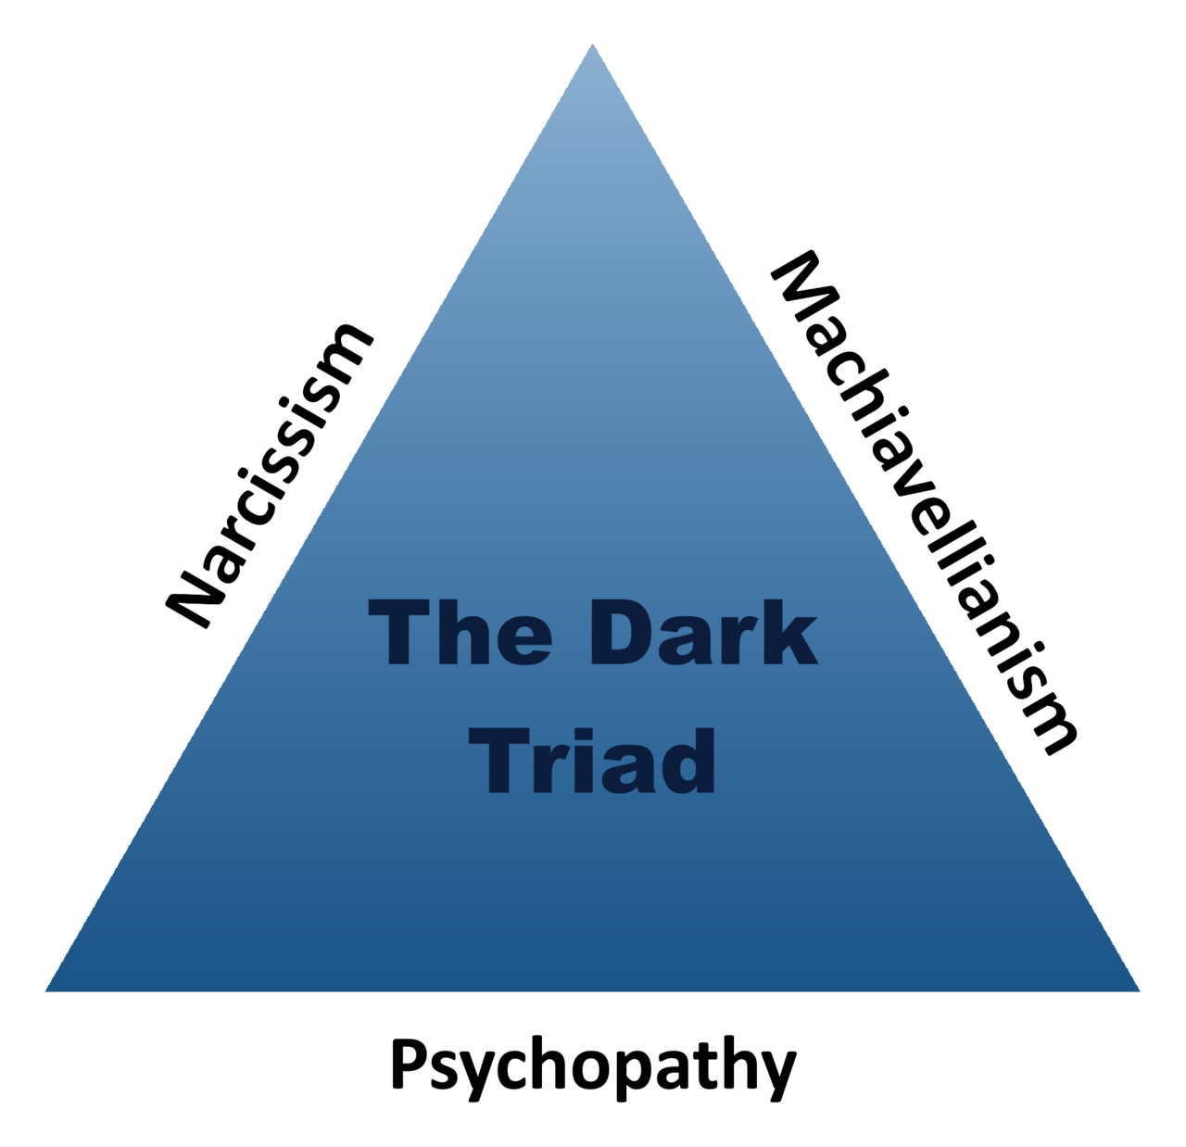
The vulnerable dark triad comprises three related and similar constructs: vulnerable narcissism, sociopathy, and borderline personality disorder.
https://en.wikipedia.org/wiki/Dark_triad

Psychopathy, sometimes considered synonymous with sociopathy, is characterized by persistent antisocial behavior, impaired empathy and remorse, and bold, disinhibited, and egotistical traits.

https://en.wikipedia.org/wiki/Antisocial_personality_disorder

What I Mean When I Say I'm Autistic: Unpuzzling a Life on the Autism Spectrum by Annie Kotowicz
https://www.amazon.com/dp/B0BJYGB57K

The Old Testament
A serial-killer plays with His pets

Blindsight and Echopraxia by Peter Watts
Serial-killers save the world

Vampire Hunter D: Bloodlust (2000)
Serial-killer falls in love, with a good ending

Somebody (2022)
Serial killer falls in love, with a tragic ending (for him)

Evangelion rebuilds
Mass-murderer trying to bring his lost love back from the dead

Interview with the Vampire (2022)
Sexy serial-killers navigating a love-triangle

The Vampire Tapestry by Suzy McKee Charnas
Serial-killer trying to understand himself

The Night Flier (1997)
Others trying to understand a serial-killer

ßehemoth by Peter Watts (from the rifters trilogy)
Serial-killer stops another serial-killer from destroying the world

Hannibal (2013)
Serial-killer plays with his hunters

The Patient (2022)
A serial-killer tries to control his compulsions

Let the Right One In (2008)
a succession of boys fall in love with a serial-killer

Kill Bill (2003)
a serial-killer seeks revenge against her ex-partners.

https://www.youtube.com/watch?v=UnilUPXmipM
Gabriel Faure's Requiem Op. 48 Complete (Best Recording)

https://www.youtube.com/watch?v=BV_0HqIUvRQ
Opening theme from Shigurui シグルイ Soundtrack [Full Album]

A cadaver or corpse is a dead human body.
https://en.wikipedia.org/wiki/Cadaver

overkill (noun) ˈō-vər-ˌkil
killing in excess of what is intended or required

Moral philosopher Aaron James, in his 2012 book, Assholes: A Theory, gives a more precise meaning of the word, particularly to its connotation in the United States: A person, who is almost always male, who considers himself of much greater moral or social importance than everyone else; who allows himself to enjoy special advantages and does so systematically; who does this out of an entrenched sense of entitlement; and who is immunized by his sense of entitlement against the complaints of other people.[9][10][11] He feels he is not to be questioned, and he is the one who is chiefly wronged

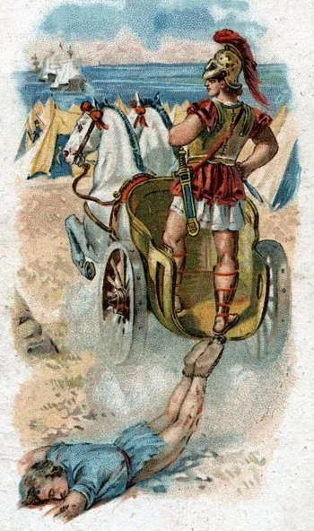

https://tvtropes.org/pmwiki/pmwiki.php/Main/DesecratingTheDead

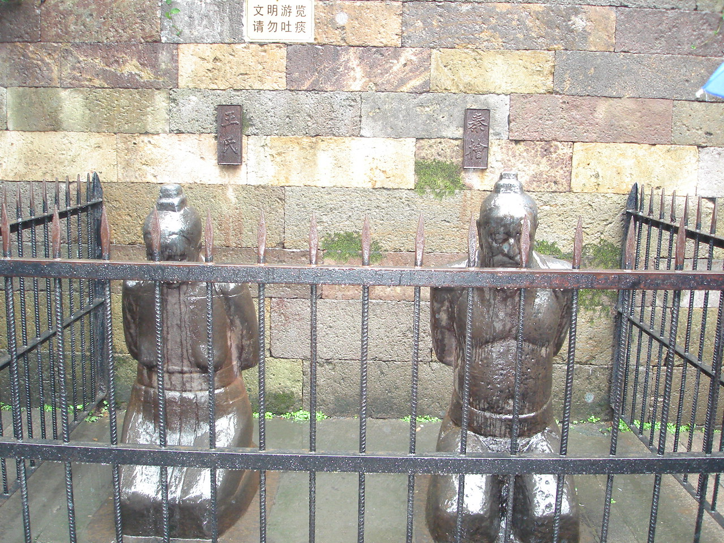
https://en.wikipedia.org/wiki/Yue_Fei#Qin_Hui's_posthumous_punishment

For their part in Yue's death, iron statues of Qin Hui, Lady Wang...were made to kneel before Yue Fei's tomb. For centuries, these statues have been cursed, spat and urinated upon by people.

Monsters are very often depicted as dangerous and aggressive with a strange, grotesque appearance that causes terror and fear.

Monsters may also be depicted as misunderstood and friendly creatures who frighten individuals away without wanting to, or may be so large, strong and clumsy that they cause unintentional damage or death.

https://en.wikipedia.org/wiki/Monster

Modern vampire treatment in popular culture is usually divided into cycles. The Malignant cycle (1931 -1948), the Erotic cycle (1950 -1985), the Sympathetic cycle (1987 -2001), the Individualist cycle (2003- present day). Malignant, meaning vampires are treated as creatures of pure horror, as popular in the early films like Nosferatu, and Universal films. Erotic, meaning they were considered evil but alluring, such as the Hammer films. Sympathetic, meaning they were seen as tragic monsters that were to be pitied, but still feared, although they could sometimes be redeemed usually by becoming human once more. And Individualist meaning that they could be bad, good, or in between, much like humans, and their transformation to vampirism did not imply a change in morality.

https://tvtropes.org/pmwiki/pmwiki.php/Main/OurVampiresAreDifferent

https://soundcloud.com/ztutz/sets/iolet-music-from-the-world-of-anathem
IOLET :: Music from the World of Anathem

1 Approximating Pi
2 Thousander Chant ←-- money
3 Proof Using Finite Projective Geometry
4 Cellular Automata
5 Mascheroni Circles
6 Quantum Spin Network ←-- money
7 16 Color Prime Generating Automaton
8 Deriving the Quadratic Equation

https://www.youtube.com/watch?v=mbLiDjxPTYs
Naka-Choko

https://www.youtube.com/watch?v=Lqq6Ge0p6Yc
Bloodfest (From Mizumono)

https://www.youtube.com/watch?v=5n8iU7abqkQ
Quake - Soundtrack [Full Album]

00:00 Intro
05:07 Aftermath
07:32 The hall of souls
15:52 It is raped
21:56 Parallel dimensions
29:20 Life
37:58 Damnation
43:34 Focus
50:02 Falling
53:34 The reaction

https://www.youtube.com/watch?v=1VN9TBfWAEo
Become Desert by john luther adams
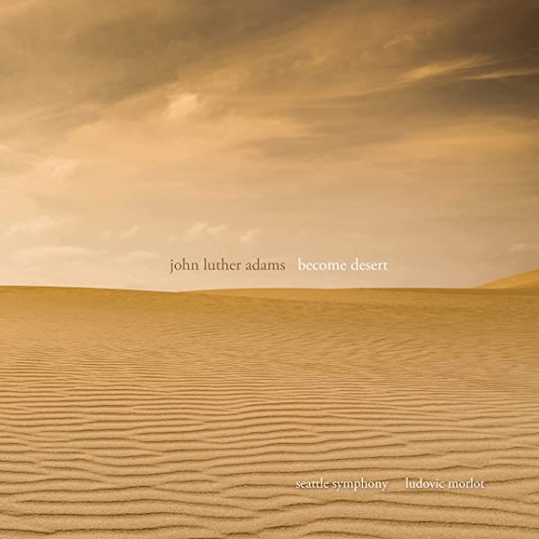

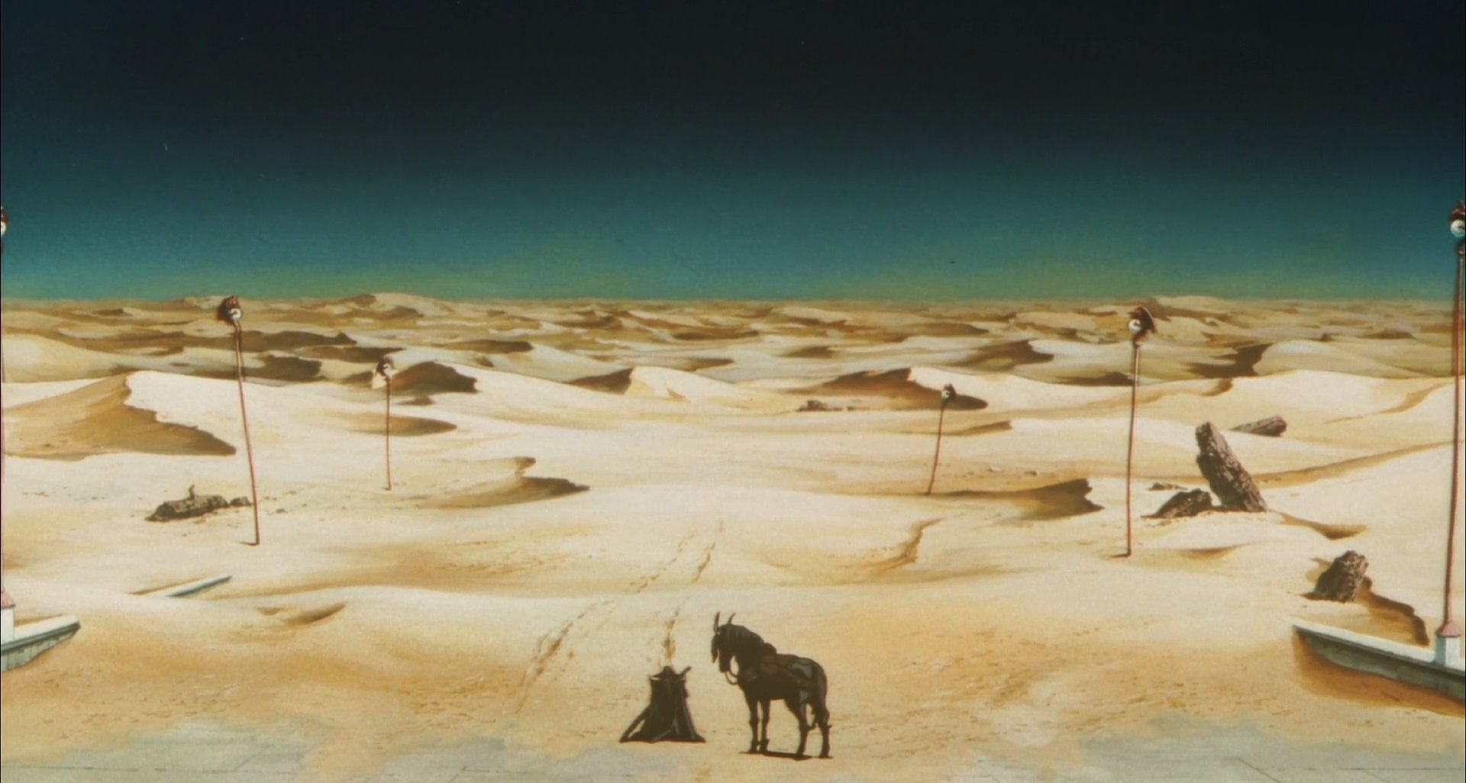

If one looks deep enough, they may see a monster in me
Hell, I sometimes see a monster in myself
because the monsters I see in fiction
are so damn sexy.

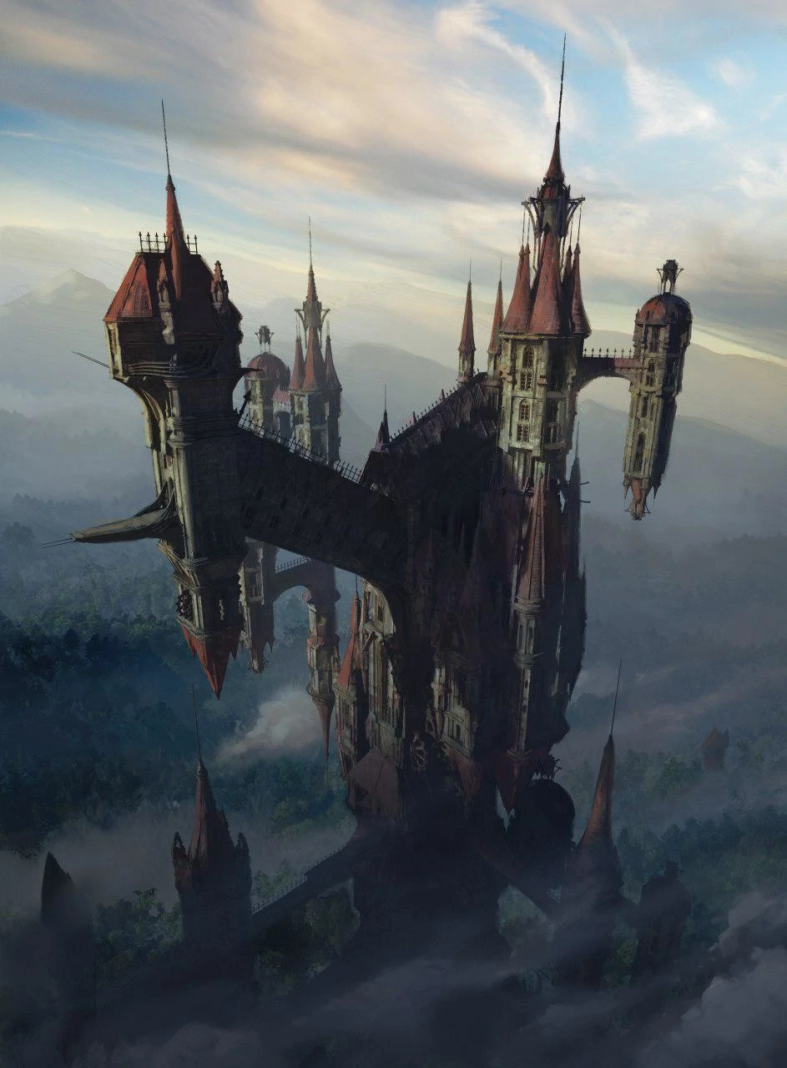
That’s a vampire’s home...

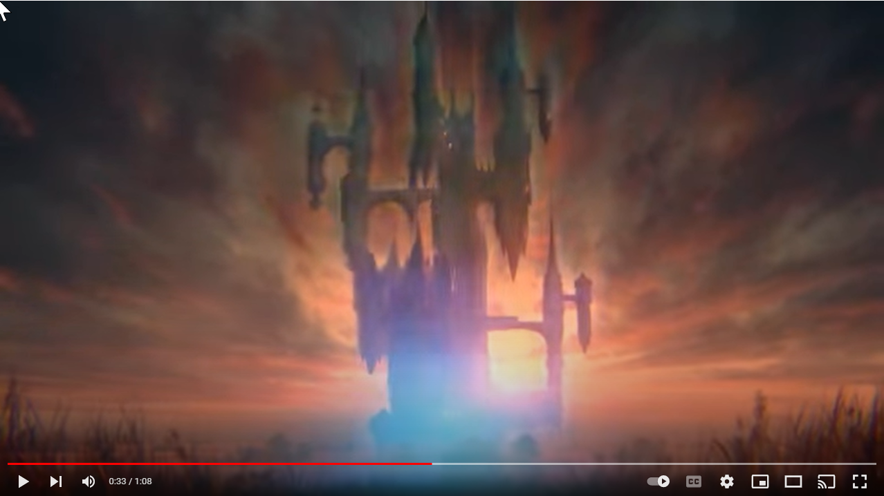

https://www.youtube.com/watch?v=XS91q20TVbQ
Castlevania Season 2 - Dracula "Moves" the Castle

...And it teleports!!!!

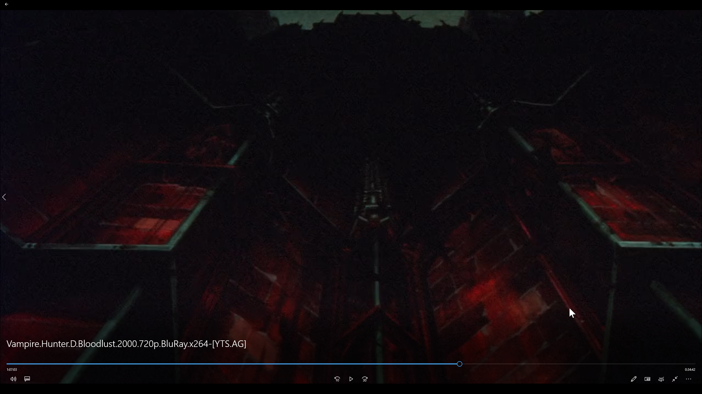
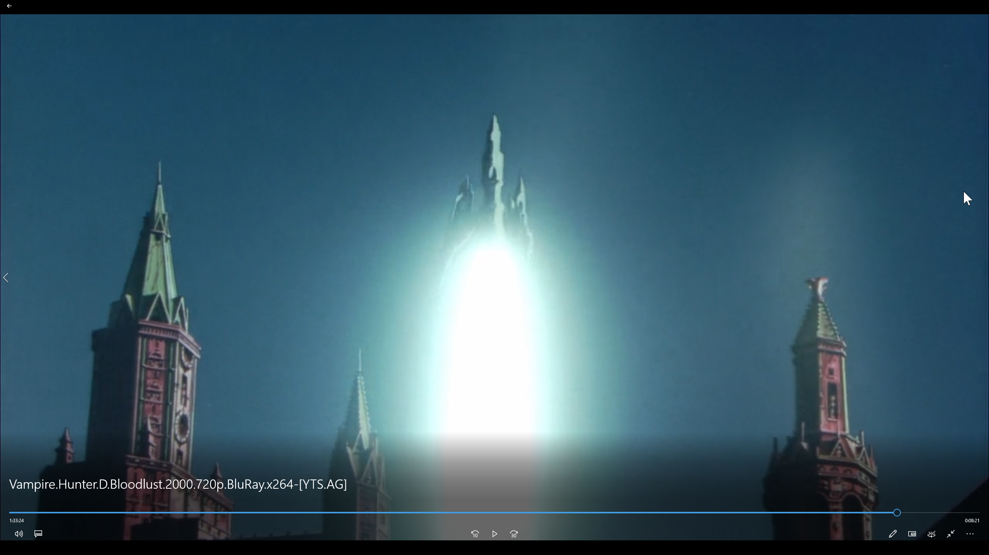
The vampire’s castle in Vampire Hunter D: Bloodlust (2000) has a manned rocket in the backyard.


Ikari Gendo’s specs 😍.

Peter Watts also has Jukka wearing wraparound visors to keep from scaring the “cattle”.

Look at Hannibal (the cannibal’s) sense of style in his clothing and his office.
@1502pm
Hands are sore. Let’s resume later, shall we?

FIN
https://www.youtube.com/watch?v=dGva1NVWRXk
Become Ocean

